WILMCOTE PARISH COUNCIL

ANNUAL PARISH COUNCIL MEETING

To be held in Wilmcote Village Hall at 7.30 p.m. on 18th May 2022.

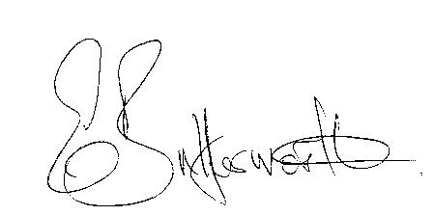

Clerk to the Parish Council 13th May 2022

AGENDA

Election of Chairman
Record of members present
Apologies for Absence
To receive the Chairman’s Declaration of Acceptance of Office
Declaration by Councillors of any changes to their Declarations of Interest as shown on the public register.
Election of Vice Chairman if required
Appointment of Internal Auditor
Statement of Finances as at 31st March 2022
Approve following standard items included in Precept for payment:

HMRC PAYE & NI - Quarterly
Clerks salary - monthly
WALC subs – annual
SDC Website hosting – annual
Npower energy
E.on maintenance
Zurich Insurance - annual
G. Compton for grass cutting – The Green
Auditors - internal and external – annual
S137 grants once agreed by Cllrs.- annual
ICO annual
CPRE annual

PLAYGROUND
Gary Compton – grass and hedge cutting plus litter picking
SDC Lease 6 monthly
Monthly inspections
Annual inspection

Followed by
ORDINARY PARISH COUNCIL MEETING

- To receive written requests for Disclosable Pecuniary Interests

- To approve for signature the minutes of the ordinary Parish Council meeting held on 23rd March 2022.

- Public participation.

- County & District Councillor’s reports.

- Annual Accounts of Wilmcote Parish Council for 2021/2022.

- Planning Applications – status of current planning applications.

Consideration of Planning Application No. 22/00894/FUL The Laurels, The Green, Wilmcote: Application for Hair Dressing business within the grounds of property within outbuilding.

- Correspondence received and previously circulated will be taken as read.

- Willow Wood Play Area update.

9. Queen’s Platinum Jubilee fund update.

10. Keep Fit/Tai Chi belated application for funding.

11. Verge protection posts on The Green.

12. Community Speedwatch update.

13. Car parking on Glebe Estate.

14. Neighbourhood Watch.

15. Countryside Wilding project update.

16. Defibrillator awareness session update.

15. Items for the agenda for the next meeting.

16. Date of next meeting: 20th July 2022 .

