PARISH OF WILMCOTE

A meeting of the Parish Council for the above named Parish will be held at Wilmcote Village Hall on 24th May 2023 at 7.30pm

Dated this 19th day of May 2023
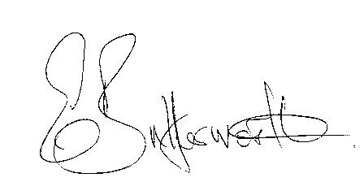Clerk to the Parish Council

WILMCOTE PARISH COUNCIL ANNUAL MEETING

Sign Declarations of Acceptance of Office

AGENDA

Election of Chairman
Record of members present
Apologies for Absence
To receive the Chairman’s Declaration of Acceptance of Office
Declarations of Interests in items on the agenda
Election of Vice Chairman if required
Appointment of Internal Auditor
Statement of Finances as at 31st March 2023
Approve following standard items included in Precept for payment:

HMRC PAYE & NI - Quarterly
Clerks salary - monthly
WALC subs – annual
SDC Website hosting – annual
Npower energy
E.on maintenance
Zurich Insurance - annual
G. Compton for grass cutting – The Green
Auditors - internal and external – annual
S137 grants once agreed by Cllrs.- annual
ICO annual
CPRE annual

PLAYGROUND
Gary Compton – grass and hedge cutting plus litter picking
SDC Lease 6 monthly
Monthly inspections
Annual inspection

Followed by

ORDINARY PARISH COUNCIL MEETING

- To receive written requests for Disclosable Pecuniary Interests.
Hand over new Declaration of Interests forms to Clerk.

- To approve for signature the minutes of the Annual Parish Assembly meeting and ordinary meeting held on 22nd March 2023.

- Request from Mr. McMillan for co-option onto the Council.

- Public participation.

- County & District Councillor’s reports.

- Annual Accounts of Wilmcote Parish Council for 2022/2023.

- Planning Applications – status of current planning applications.

Consideration of Planning Application Nos. 23/00980/FUL and 23/00981/LBC Masons Arms, Wilmcote.

- Correspondence received and previously circulated will be taken as read.

- Willow Wood Play Area update.

10. Footway Lighting update.

11. Defibrillator awareness session update.

12. Community Speedwatch update.

13. Mobile Warm Hub - WRCC

14. Lead Councillors’ responsibilities update

15. Councillors reports and items for the agenda for the next meeting.

16. Date of next meeting: 19th July 2023.

