MINUTES OF THE PARISH COUNCIL MEETING HELD AT WILMCOTE VILLAGE HALL ON WEDNESDAY 20th SEPTEMBER 2017 – NO. 93
- Present: Cllr. Ray, Chairman, Cllr. Massey, Cllr. Lowis, Cllr Fraser, Cllr McMillan and one member of the press.
- Apologies: Cllr. Stewart, County Cllr. Cargill and District Cllr. Lawton

3. Written requests for dispensation for Disclosable Pecuniary Interests
where that interest is not already in the register of members’ interests.
No written requests were received.
4. Co-option of Councillor:
Deferred to the next meeting.
5. To approve for signature the Minutes of the Parish Council meeting held on 19th July 2017.

These minutes were approved by all members and signed by the Chairman.
6. Public Participation:

There were no members of the public present.

7. County & District Councillor’s reports:
District Cllr. Lawton provided a report ahead of the meeting and this is attached on page 6.
8. Car Parking proposals in Wilmcote:
The Parish Council had been approached by The Shakespeare Birthplace Trust and Mr. Russell-Wilkes of Godfrey-Payton, on behalf of Mr. & Mrs Tucker, with draft proposals for establishing new car parking facilities in Wilmcote. After some consideration it was agreed that the Parish Council would initially host a public meeting for both representatives to present their plans and give the residents an opportunity to state their views. The Clerk was asked to arrange a date and for a flyer to be printed for each household. Cllrs. Massey and McMillan agreed to organise delivery of the notices. Cllr. Ray proposed that 3 Councillors should meet with a planning officer at SDC should these draft proposals proceed further.
9. Planning Applications: status of current planning applications:
Planning Application No. 17/01267/OUT 1 The Orchard, Wilmcote: Outline application with all matters reserved except for access for the erection of up to 4 residential dwellings and associated works including demolition of part of single-storey garage forming part of Arden View (no.2 The Orchard). Refused.
Planning Application No. 17/01156/VARY Dunroaming Stable, Gospel Oak Lane, Pathlow: Vary Condition 1 of planning permission 13/02697/VARY to allow a permanent change of use or further temporary period for the change of use of the land for the stationing of caravans for residential purposes for 1 no. Gypsy pitch and ancillary works including septic tank and hardstanding. Permission with conditions.
Planning Application No. 17/01317/FUL Woodcot Mobile Home Park, Aston Cantlow Road, Wilmcote: Full application for use of land for siting of 2 additional caravans for residential purposes in addition to the 50 caravans existing. (52 in total). Withdrawn.
Planning Application No. 17/01435/FUL Turnlea, 13 Old School Lane, Wilmcote: Replacement dormer bungalow together with one additional dwelling. West Area Committee 27th September 2017. Cllr. McMillan offered to attend the meeting and speak on behalf of the Parish Council.
Planning Application No. 17/01449/FUL Loughrigg, Hardwick Rise, Pathlow:
Proposed porch and side extension. Permission refused.

Planning Application No. 17/01528/VARY Hill House, Birmingham Road,
Pathlow: Variation of condition 1 of planning permission 16/01080/FUL.
Variation permitted.

Planning Application No. 17/02159/TPO Wilmcote Sports and Social Club,
Aston Cantlow Road, Wilmcote: T1 ( TPO/005/001/T3 ) - Ash – Fell. G1and
G2(TPO/005/001/G2 ) - Ash x 2 - Cut back overhanging branches over track
by up to 3m. Permission granted.

The following application notification was received after the agenda was
circulated:

Planning Application No. 17/02610/FUL 26 Marsh Road, Wilmcote: Ground
floor extension to include the rebuilding of substandard garage.

After due consideration all Cllrs. present agreed they had no concerns over
the proposals. Cllr. Ray proposed a response of No objection and this was
seconded by Cllr. McMillan.

10. Progress report:

Vehicles inconsiderate parking in Station Road near to the railway station: The local PCSO’s will be monitoring the situation and utilise advisory notices on the cars causing unnecessary obstruction.

Stratford on Avon Gliding Club have not been able to arrange an open day this summer but may well arrange one next year for all the local communities. They will keep us informed.

All other progress is noted under individual agenda items.
11. Correspondence:
- Invitation from the Chairman and Consort of WCC to Open Evening & Reception on 16th September 2017.
- Member training – Community Safety Workshop 21st September 2017.
- Stratford District Member training – Using Social Media for Community Engagement 5th October 2017. Cllr Fraser expressed an interest in this workshop but unfortunately will be out of the country on this date.
- Confirmation received from Grant Thornton that the annual audit has been satisfactorily completed.
- A resident reported that the notice board by Glebe Estate is very loose in the ground and the uprights are rotting. From a photograph provided it was agreed by all that it appears to be unsafe and should be taken away. Cllr. McMillan agreed to remove it and Cllr. Ray offered to assist if required.
- Mrs. Stacey has passed a copy of her latest letter to the Clerk as the issue with the security lights shining into her bedroom has not been satisfactorily addressed. The Clerk was asked to contact the housing officer and, if necessary, the Chief Executive of Orbit Heart of England asking what action they propose taking to resolve the matter for once and for all.
- The Chairman received an email from a resident expressing concern over the length of timber in the road by Mary Arden’s overflow car park and asking if we can take some action to have it removed. The Clerk was asked to contact the site Manager with this request.
12. Wilmcote Parish Council Emergency Plan:

Cllr Stewart has asked Cllrs. if they wish to put forward any proposals. If none are forthcoming she will formally table the plan for approval at the next meeting.

13. Willow Wood Play Area update:

There is a loose slat on the zipwire platform and this has warped so may need replacing. The Clerk asked Cllr. McMillan if he would have a look let her know if a new piece of timber is required or he feels it can be screwed down satisfactorily.

Cllr. Ray suggested that it would now be a good idea to start looking into arranging for a new roundabout to replace the one that had to be removed last year. Cllr. McMillan will investigate possibilities.

16. Neighbourhood Plan update:
The Plan is complete and due to go to the Cabinet meeting in October for approval prior to proceeding to referendum.
17. Road Traffic items:
School Safety Zone:
Following a meeting with County Cllr. Cargill three developments are proposed:
1. Install flashing 20mph (or even 10mph) signs at either end of Church Road.
2. Make the rear entrance into the school through the church the main access for children. Work will be required to provide new security fencing and gate, any improvements within the school will need to be identified and completed.
3. Remove/trim back the hedge alongside the existing playground to widen the pavement.

Cllr. Cargill has briefly explored the possibility of flashing signs but there is a potential problem in that BT may not give permission to mount a sign on their pole and highways may not permit such a sign in the conservation area or indeed permit a 20mph zone.

Cllr Cargill is away on holiday at present but we will be getting back in touch with him on his return.
Community Speedwatch scheme:

Cllr. Massey reported that the training has been completed by seven volunteers from Wilmcote and two from Great Alne and all passed the necessary test afterwards. We are currently waiting for PCSO Morris to carry out a risk assessment for the safety of the volunteers when using the equipment.

18. Payment of outstanding invoices:

There were no outstanding invoices.

17. Councillors’ reports and items for the agenda for the next meeting:

Items for the next agenda to include:

Willow Wood Play Area
Neighbourhood Plan
Road Traffic Items
Community Speed Watch scheme
Parish Council Emergency Plan

18. Date of next meeting: 15th November 2017.

No further business – Chairman closed the meeting at 9.00 p.m.

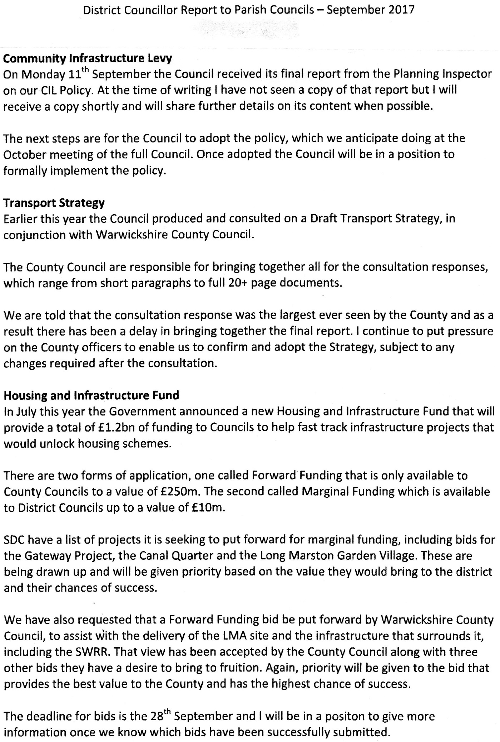

For information only:

The following payments were made between meetings:

CPRE £ 36.00 BACS
Colemans Office Supplies 108.43 BACS
E.on (repair) 68.40 BACS
Wilmcote Village Hall 42.00 (100572)
C.P.Wheeler (grass cutting) 60.00 (100573)
E.on (maintenance) 137.44 BACS
Grant Thornton (Audit) 240.00 BACS

WILLOW WOOD PLAY AREA:

Playground Supplies Ltd (Inv 5453) 72.00 BACS

NEIGHBOURHOOD PLAN:

Kirkwells 1,680.00 BACS

