MINUTES OF THE PARISH COUNCIL MEETING HELD AT WILMCOTE VILLAGE HALL ON WEDNESDAY 21ST JULY 2021.
NO 115

1. Present: Cllr. Ray, Cllr. Shilvock, Cllr. Simmons, Cllr. Stewart, Cllr. J. Lee, Cllr. E. Lee, Cllr. McMillan, District Cllr. Shenton and twelve members of the public.

Part meeting: County Cllr. Daniell

2. Apologies: There were no apologies.

3. Written requests for dispensation for Disclosable Pecuniary Interests
where that interest is not already in the register of members’
interests.
No written requests were received.

4. To approve for signature the Minutes of the Annual Parish Council meeting and ordinary Parish Council meeting held on 17th March
2021.

These were agreed by all members for signature by the Chairman.

5. Public Participation:
A number of objections and concerns had been expressed prior to the meeting relating to the VAS sign installed in Church Road opposite Swanfold and several residents had indicated a desire to speak at the meeting.
In order to give all members of the public the opportunity to do that we pre-agreed an extended public participation session starting at 6.45 p.m for an extra three quarters of an hour.
Comments and questions were basically in line with the written expressions of concerns with one or two additional comments, in particular about the rules and regulations for conservation areas. As this initiative was carried out in conjunction with Warwickshire Highways the concerns need to be carried forward to Mr. Stanley who is currently on leave. Upon his return the working group will arrange a meeting with him to discuss these concerns.
Cllr Ray thanked the public for attending and invited them to stay or the rest of the meeting as observers if they wished.

6. Correspondence:
All Correspondence circulated electronically to date was taken as read.

The quarterly financial statement for the first quarter was circulated to Cllrs.

7. County & District Councillor reports:

District Cllr. Shenton and County Cllr. Cargill provided reports and these are attached at the end of the minutes.

8. Planning Applications:

Status of current applications circulated to Councillors prior to the meeting.

Application No. 21/02132/FUL Moor Farm, Billesley Road, Wilmcote: Widening horse exercise track by 7m.
Cllr. Simmons proposed supporting this application as the proposal will have minimal impact and the Parish Council is happy to support this local businesses. Cllr Shilvock seconded this proposal and all Cllrs were in agreement.

9. Lone Worker Policy:

Deferred.
10. Willow Wood Play Area:

The new noticeboard has been installed and no issues were raised from the July inspection. There has been a further delay on installation of the new pieces of equipment and this is now expected to start on the 27th July.

There is no longer a dedicated mobile phone, emergency services should be contacted if the need arises and a notice to this effect will be placed in the new noticeboard. The Clerk can be contacted by email if necessary for reporting faulty equipment etc..

11. Application requesting the Mary Arden Inn to be added to the
District Council list of Community Assets.

An application has been completed and submitted to the relevant Officer.

12. Road Safety items:

The remainder of the works in Church Road have been completed with the installation of the VAS signs. One of these being the subject of concern raised by members of the public.

13. Revised Standing Orders:

The review team completed work on the Standing Orders, they were circulated prior to the meeting and all Cllrs. indicated their approval.

14. Community Speedwatch update:

A short update was received from the team advising that sessions had taken place in June mainly in Station Road and details of a number of vehicles have been passed to Warwickshire police for further action. A useful session has been held with the Great Alne CSW Group which is now up and running. Despite a recent request no new volunteers have been forthcoming. They will continue in their efforts to recruit new members.

15. Items for the agenda for the next meeting:

Lone Worker policy

16. Date of next meeting: 22nd September 2021

No further business, the Chairman closed the meeting at 8.40 pm.

Wootton Wawen Ward - District Councillor’s report as at 20/07/2021
Garden Waste subscription
Just as a reminder, if you haven’t subscribed and are not displaying a permit on your green bin, it won’t be emptied.

Blue Bins – recyclable waste
You may have seen the news that there was a fire at the MRF facility that we use at Ettington and effectively we cannot use this facility at present. We are trying to find alternative destinations for our recyclable waste and therefore we have had to suspend this service until Biffa are able to resolve this issue of where our recyclate waste can be handled. We believe this to be a short suspension of the service and I will update the meeting further.

General
I have been heavily engaged over the last three months on preparing the Climate Change Ambitions Paper with the Director for Climate Change and my opposite number at Warwick DC. This paper was covered by The Herald with a front page quote from me and a 2 page spread inside. Hopefully you will have had time to read it but I’m happy to give a summary at Monday night’s meeting if you wish. In my opinion whilst we committed to net zero by 2030 having looked at the data and taken expert advice my view is very much that the best we can do is 55% by 2030 and even that is a tall order and will require big changes in everything we do. I feel that we must plane for a 3 degree rise in global temperatures and hope we can mitigate but it is clear that we will need to adapt to the changes that such a rise will bring to our weather, food production, disease, eating habits, the way we move around and the effects on bio diversity. A lot of what is in the ambition paper will need changes in government policy, legislation and lots of funding centrally for us to be able to do anything major. I’ve copied the statement on Intent on Climate Change further down (developed jointly with Warwick District Council).This has been approved by both Councils. The statutory Climate Change Committee is very unhappy about progress, especially on adaptation with the UN and the International Energy Authority also sounding warnings about the lack of progress. In addition, just this weekend The Times reported that the government have delayed their report on the way forward for transport and a separate report on Gas boilers….what a surprise….it would appear that the costs are frightening government and voters. What we must always bear in mind is that the UK is responsible for only arounf 1% of all greenhouse gas (GHG) emissions worldwide, whatever we do will have very little impact, it is a token gesture. Sound bites are great for the newspapers, they then require actions. Will our Government now step up to the challenge, it remains to be seen because the best course of action is to persuade the USA, China, India and Japan to commit to ending the use of fossil fuels which despite all of the rhetoric, they have not

Police
A gentle reminder that Sgt Ebbs has indicated that he is willing to attend a future meeting if you would like to ask questions.

Garden waste subscription scheme
As at Monday 19/07/2021 we had over 47,000 subscriptions raising over £1.7m. Details from other districts within the County show that whilst we have managed to reach over 75% of our residents, the best in the other districts within our County was 63% with one at 53% and the other at less than 40%. A word of caution though, so many staff at Biffa are being “pinged” by the NHS app that we are starting to get concerned that we may have critical staff shortages. I will let you know in plenty of time if we are forced to make any changes to services but at this moment in time we have the situation under control.

Planning Enforcement
If you have any comments to make on the proposed changes in triaging and structure of the team, which is a non-statutory service, you should get them in quickly as the consultation has closed but it is not too late to get them in and they will be considered. If you’re unsure about this consultation I can give you some more detail.
Covid-19

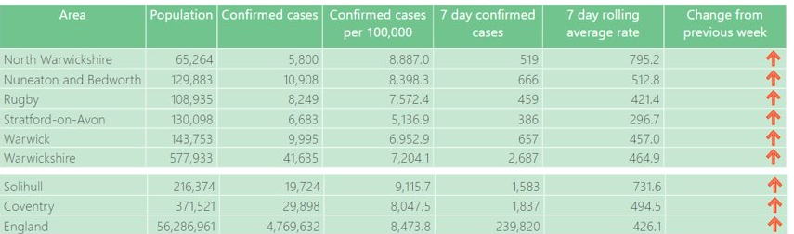

The numbers don’t make great reading as they continue to increase at present, but thankfully hospital admissions and deaths are still relatively low. The biggest issue amongst hospitals is the number of staff having to self-isolate.

The table below shows that the 25 to 29 age group is the least protected and nationally we are seeing less young people coming forward for their first and second vaccinations with quite a steep fall off in the number of vaccinations being carried out daily.

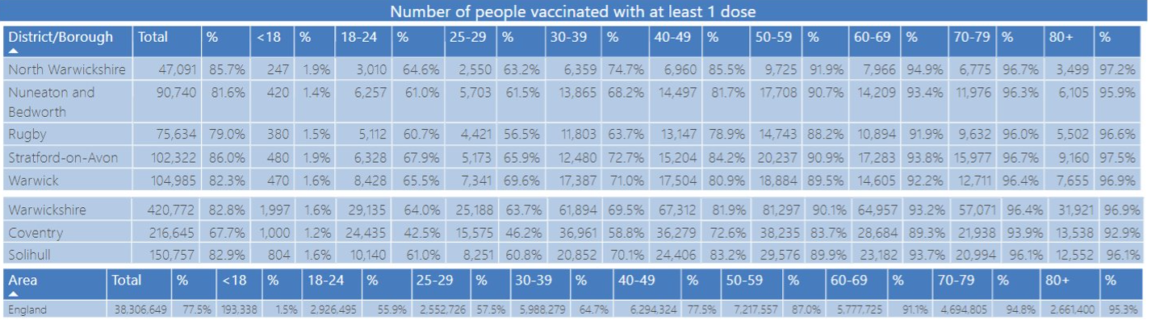

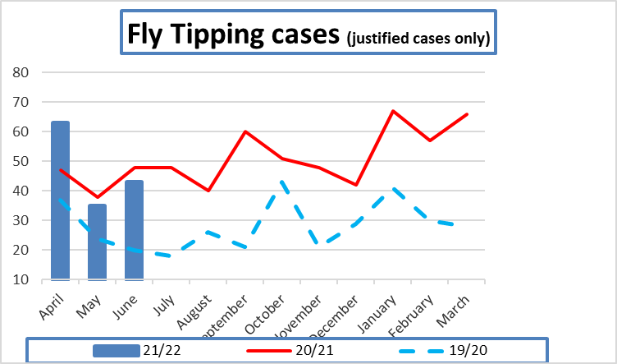
Thankfully fly tipping incidents over the last two months have started to fall below the 2020/21 levels and there is no evidence that those incidents are caused by the green waste charge.

In addition more appointments have been made available for the HWRC sites (tips/dumps) and booking will continue to be a feature as this has worked well and avoids queuing.
CLIMATE CHANGE AMBITIONS PAPER

Climate Emergency
Shared Ambitions for Stratford-on-Avon DC and Warwick DC
June 2021

Statement of Intent
- In 2019, both Councils declared a climate emergency and in doing do so set out ambitions to reduce both organisational and District carbon emissions. Whilst the specific ambitions were slightly different, the overall intent was the same.
- The Councils’ have engaged specialists to compile a detailed report (attached as Appendix B) to inform the two Districts about the nature and extent of interventions needed to achieve emissions reductions within South Warwickshire. This report indicates that with a high level of ambition, a 55% reduction in carbon emissions from across South Warwickshire is feasible by 2030;
- Since the declaration of the Climate Emergency, both Councils have taken steps to reduce carbon emissions, the details of which are set out in Appendix A.
- This paper sets out the shared ambitions for South Warwickshire taking account of:
- the advice from the Anthesis report;
- the extent to which cooperation from other organisations is required;
- the availability of funds both from Central Government, other external funds and the limited funds from the Councils’ own budgets;
- the many uncertainties of external factors that might either hinder or accelerate our progress;
- the need to fully play our part in achieving the ambitions as clear statements of intent;
- the need to ensure the climate emergency is a consistent priority within each of the Councils’ decisions and projects - without that consistent prioritisation, we recognise that these ambitions cannot be achieved;

So, as we set these ambitions, we understand that there are many uncertainties, and we recognise that the path towards net zero will need to change as the context changes. These ambitions therefore need to be understood as aspirations rather than firm commitments. But we do make a commitment to play our part in working to achieve these ambitions and ask others nationally, regionally and locally to join us on that journey.

Weekly Update Warwickshire County Council
Alcester Division

Covid-19:
Step 4 of the roadmap will proceed as planned on Monday. Moving to Step 4 is a balance of risks and the we should continue to be cautious and implement a degree of personal responsibility.
Although the latest changes will give us more freedom, we must remember that we are still living with COVID-19 and that it has not gone away. Lots of things are changing at the moment, and you can now meet in groups of any size indoors or outdoors. It is expected and recommended that people wear face coverings in crowded areas such as public transport.
In the county Household Waste Recycling Centres will see parking increase and bookings across the sites to allow another 5,000 bookings a week, an increase of about 1/3 on current booking availability.
Libraries will remove the requirement for social distancing. Each library will have a maximum occupancy level based on air flow and ventilation, set at a level of 50 % of the maximum capacity and will be reviewed on a weekly basis. Staff and the public will be asked to wear face coverings. Events and activities will be reintroduced in a measured way and will initially be bookable in order to manage numbers. The number of Public Network computers will be gradually increased as will study spaces.
Market Hall Museum and County Record Office will broadly follow the above approach. The museum will remove pre-bookings and operate at 50 % capacity during the initial period of opening.
Across Warwickshire there were no new deaths recorded on 15th July from the previous day although for the same period we recorded 527 cases which is the highest daily total since records began and surpass 492 which was recorded in January. Stratford and Warwick areas interestingly though recorded a drop in the 7-day rolling average.
Community Ownership Fund:
The Community Ownership Fund will provide £150 million over four years to support community groups in England, Scotland, Wales and Northern Ireland to take ownership of assets and amenities at risk of being lost. Voluntary and community groups can bid for match funding to acquire important assets and run them for the benefit of the local community.
The Fund will run until 2024/25 and there will be at least eight bidding rounds in total. The prospectus contains details for round one and provides detailed guidance on the purpose of the fund, eligibility criteria, funding and support assessment criteria and the decision-making process.
Prospectus: https://www.gov.uk/government/publications/community-ownership-fund-prospectus
Assessment criteria: https://www.gov.uk/government/publications/community-ownership-fund-assessment-criteria-guidance
Hospital to Home Services:
As Piers sits on the Resources and Fire & Rescue Overview and Scrutiny Committee, he would like to remind the community about the Hospital to Home Service which is supported by the Fire service in helping the elderly and vulnerable patients get home following treatment. It appears the service is working well and provides patients with a trusted and safe pair of hands while relieving our hospitals and nursing staff.
Warwickshire Property and Development Group:
Warwickshire Property & Development Group (WPDG), set up to deliver new affordable and market-priced homes and a range of commercial, mixed-use and renewable energy opportunities across the county, has been launched by WCC.
Read more: https://www.warwickshire.gov.uk/news/article/2255/warwickshire-county-council-launches-warwickshire-property-development-group-wpdg
Warwickshire Police – Report it online
Please remember that anti-social behaviour and Road Traffic Incidents that do not require police attendance can now also be reported online via Warwickshire Police.
Report it online here: https://www.warwickshire.police.uk/
Updates:
Please be aware that Mark and Piers post regular updates to /AmazingAlcester/ – but we are also keen to share good news. If you have any stories that you want us to share please let us know.
www.facebook.com/amazingalcester/
www.twitter.com/amazingalcester/
www.instagram

