MINUTES OF THE PARISH COUNCIL MEETING HELD USING ZOOM VIDEO CONFERENCING ON TUESDAY 27TH April 2021.
NO 114

1. Present: Cllr. Ray, Cllr. Shilvock, Cllr. Simmons, Cllr. Stewart,
District Cllr. Shenton and one member of the public.

Part meeting: County Cllr. Cargill

2. Apologies: Cllr. McMillan, Cllr. J. Lee and Cllr. E. Lee

3. Written requests for dispensation for Disclosable Pecuniary Interests
where that interest is not already in the register of members’
interests.
No written requests were received.

4. To approve for signature the Minutes of the Annual Parish Council meeting and ordinary Parish Council meeting held on 17th March
2021.

These were agreed by all members for signature by the Chairman.

5. Public Participation:
The member of the public attended as an observer.
6. Correspondence:
All Correspondence circulated electronically to date was taken as read.

7. County & District Councillor reports:

Cllr. Shenton provided a report, and this is attached at the end of the minutes.

Cllr. Cargill provided a report, and this is attached at the end of the minutes.

Pathlow Traveller Site: Cllr. Cargill advised that he has a meeting with the MP, Nadhim Zahawe regarding various reports received recently about issues with the site. Cllr Shenton said he has also had reports of intimidation and damage to property from landowners. The Clerk was asked to provide both Cllrs. with information to enable a log to be built up both for the MP and the Safer Neighbourhood Team, in particular Sgt. Ebbs and PC Rob Davies.

Cllr Cargill is standing down as County Cllr. and Cllr Ray, on behalf of the members, thanked him for his help and wished him every success in the future.

8. Planning Applications:

Status of current applications circulated to Councillors prior to the meeting.

Application No. 21/01186/TREE 5-7 Pear Tree Cottage, Church Road, Wilmcote – various tree works. The notification had been circulated to Cllrs prior to the meeting and all were in agreement with the proposed work subject to the approval of the Forestry and Landscape Officer.

9. Annual Income & Expenditure Account for 2020/2021:

a) The Annual Governance Statement was considered and it was agreed by all that boxes 1 to 8 be ticked as yes and box 9 was not applicable. Proposed by Cllr.Shilvock, seconded by Cllr Ray and agreed by all with a show of hands.
b) The Income & Expenditure account had been circulated
prior to the meeting. This was approved by all and signed by
the Chairman, Cllr. Ray, and the Responsible Financial Officer.

The Accounting Statement was then signed by the Chairman
and Responsible Financial Officer. Proposed by Cllr. Shilvock, seconded by Cllr Stewart and agreed by all with a show of hands.

10. Willow Wood Play Area:

The notice board has been delivered and is currently being stored by Cllr. Stewart. Permission has been given by SDC to install it on the outside of the play area adjacent to the single gate and Mr. Woodman will contact the Clerk when he is able to carry out the work.

11. Revised Financial Regulations – extension relating to standard
annual payments:

Cllr Ray had circulated a paper from the review recently carried out by the Finance Team regarding payment of standard items that form part of our Precept. The document
recommended that payment of these items can be made by the RFO without additional authorisation. With a show of hands all Cllrs present were in agreement. A quarterly statement will be circulated showing all payments.

12. Information regarding proposed new National Code of Conduct:

Whilst the advice from WALC is for Councils to adopt this new code the recommendation is to synchronise adoption with the principal authority. SDC has agreed to adopt the code and this is dependent on Warwick District Council making a similar decision. Cllr Shilvock proposed deferring this matter until further notice. All were in agreement.

13. To consider applying to add the Mary Arden Inn to the list of Community Assets:

It was suggested by a resident, proposed by Cllr. Ray and agreed by all Councillors with a show of hands that we should apply to record the Mary Arden Inn as a community asset so that if it is closed and offered for sale in the future the community would be informed and given the opportunity to purchase. The resident has also offered to draft an application form for submission to the District Council.

14. Road Safety items update:

The remainder of the works in Church Road are still pending.

15. Items for the agenda for the next meeting:

Standing Orders
Community Speedwatch
Mary Arden’s Farm

16. Date of next meeting: 21st July 2021

No further business, the Chairman closed the meeting at 8.20 pm.

Wootton Wawen Ward - District Councillor’s report as at 27/04/2021

Garden Waste subscription
Just as a reminder, if you haven’t subscribed and are not displaying a permit on your green bin, it won’t be emptied.

General
Due to the forthcoming County Council and PCC elections there are very few committees operating and those that do, such as the Licencing Committee on which I sit, are not making any political decisions during this period of purdah.
Going forward the opening and recovery of the local economy, Climate Agenda, the proposed merger with Warwick District Council or a single unitary covering the whole of Warwickshire will be the big issues.

There will be some changes in some portfolios and mine is one of them. I will hand over markets and leisure to Cllr. Matt Jennings who currently has the Local Economy and Tourism portfolio and take on the Climate Change issue, retaining the other elements of my portfolio (waste, public toilets, development of the recreation ground, grounds maintenance, all contracts, car parks and strategy). This has to be confirmed at the full Council meeting in May and there is always the (unlikely) possibility that it could be rejected.

Garden waste susbscription scheme
As at Monday 26/04/2021 we had 42,000 subscriptions raising around £1.4m. This is a substantially better result than even I had hoped for and shows the value of the service to residents. The cost of running the scheme is around £1.5m with any revenue over and above the cost being ploughed back into waste services generally (including fly tipping, street cleaning etc.).

Covid-19 (As at Monday 26/04/2021)
And the good news continues in spite of the threats of the new variants from India and South Africa is that the rate of infections are down to 8.5/100,000 from 13 last week, however, the over 60’s rate was 7.2/100,000 (2 last week) with four cases over the last seven days – so grandparents and those over 60 need to take care!
The figures when compared to other districts in Warwickshire for all ages is Nuneaton & Bedworth 32/100,000, North Warwickshire 24/100,000, Warwick 12/100,000 and Rugby 41/100,000.
Continuing this positive note, the situation regarding SWFT Hospital Beds has remained at similar levels, there is now just 1 (2) confirmed case of COVID-19 with 0 (1) patients in ICU (figures in brackets are from 16 April). Occupancy levels continue to be at 88% in respect of non-Covid patients for elective surgery and there are 55 unoccupied general and acute beds.
There have been no further Covid related deaths across Stratford District over the last two weeks which remains at 140 from the start of this second wave (28th August 2020) 37 occurring in care homes, 90 in hospital, two in a hospice and 10 at home and one in a communal establishment, out of a total of 907 all cause deaths in the district for this new second wave period.

Pathlow
I am aware of the increasing number of incidents of damage to farmers land and property plus issues with intimidation of the refuse collection team and as your Parish Clerk will confirm County are aware and taking measures to deal with the issues. I have now heard from other residents about the issues of intimidation but one of the problems that the Police face is that many of these incidents are not being reported for fear of retaliation. I will update you further at the meeting.

Flytipping
Remains at approximately 80% higher than last year but to put this into context, Warwick District Council fly tipping rates are over 130% higher. Across the country this is a major problem but, thankfully, we are not yet seeing any increases due to the introduction of the garden waste scheme. I will let you know if we do but please let Streetscene@stratford-dc.gov.uk know if you spot a fly tip. It will be cleared usually with 48 hours.
Prosecutions remain rare unfortunately due to the burden of proof required. The chart below illustrates the issue of fly tipping over the last year with 612 incidents in the year to 31/03/2021 compared to 338 the previous year.

There appears to be fly tipping at the end of the drive to the G & T site at Pathlow which is being investigated.
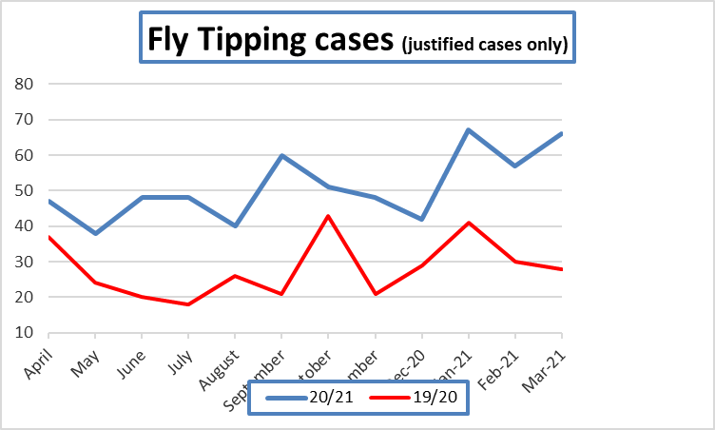

Community Speedwatch
The Police have been in touch with me as the Coordinator for the Wootton Wawen group and I am hoping that the training will commence soon. I will be in touch with your group as I’d like to loan your gun from time to time if possible and get some advice.

Other Matter
Markets returned to Stratford on Friday 16th April and have proven to be as popular as ever. On Sunday Stratford Town Centre and the markets were very busy but overall footfall is still well down on 2019 levels (the last comparable year)

The chart bellows illustrates this.
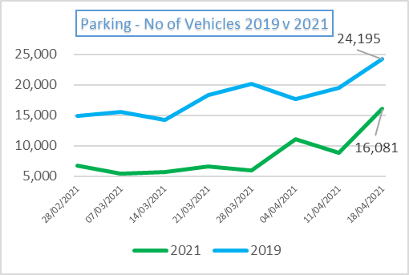

Hopefully we will remain on track for all restrictions to be lifted in June.

The Shakespeare Birthplace Trust have announced their plans for their properties which will see Mary Arden’s Farm being reopened in a limited way for educational purposes. Their announcement states the following

…..from 26 April 2021, Mary Arden’s Farm will operate as a dedicated outdoor education space this year with special access for local and regional primary schools, offering pupils an authentic Tudor learning experience and bringing Shakespeare to life in a positive and COVID-safe environment. Opening in this way as an exclusive site for schools allows the Trust to meet its charitable objective to promote the appreciation and study of William Shakespeare.

Feel free to contact me if you need further details.

Remember “Hands….Face…Space”

Cllr Ian Shenton
District Councillor for Wootton Wawen Ward (Wootton Wawen, Langley, Preston Bagot, Billesley, Bearley, & Wilmcote) – Tel 07971 343073 or 01564 795360

Lockdown rules from 12/4/2021 (with acknowledgment and thanks to The Times)
STEP TWO: April 12
Shops, museums and hairdressers
Non-essential shops, public buildings such as libraries and museums, and personal care services such as hairdressers and nail salons will all be allowed to reopen.
People from separate households will still not be allowed to meet indoors, however, so people will be asked not to visit a library or museum with people they do not live with. Driving lessons will begin again at the same time.
Pubs and restaurants
Pubs and restaurants will be allowed to offer table service outdoors. There will be no curfew and no requirement for pubs and bars to serve food alongside drinks, putting an end to the debate over whether a scotch egg constitutes a substantial enough meal.
Gyms and leisure centres
Indoor leisure facilities, including gyms, swimming pools and indoor tennis courts, will reopen but again people will not be allowed to visit them with those they don’t live with.
Outdoor attractions including zoos and theme parks will also be able to reopen their doors.
Holidays
There will be a limited return to domestic holidays for families, with campsites and holiday lets where indoor facilities are not shared with other households given the green light to reopen.
Weddings and funerals
Funerals will be allowed with up to 30 people, and the number of people permitted to attend weddings will go up from six to 15.
Larger events
At this point, the government plans to start piloting events with larger crowd sizes and reduced social distancing, using mass testing.
STEP THREE: May 17
Social contact
Outdoor social contract rules will be lifted so gatherings of up to 30 people will be allowed.
Inside, people will be able to meet subject to the rule of six or a larger group from two individual households.
Pubs, restaurants and hotels
Pubs and restaurants will also be able to reopen for indoor service. Cinemas, children’s play areas, hotels and B&Bs will also open.
Theatres and larger venues
Theatres, concert halls and other large venues will also be allowed to reopen with social distancing measures in place.
Larger indoor venues will be allowed to reopen with a maximum capacity of 1,000 or until they are half full, whichever figure is lower.
Outdoor venues will be allowed to open with a capacity of up to 4,000 people or half full, whichever is lower.
The largest outdoor seated venues, such as football stadiums, will be able to reopen with up to 10,000 people or until they are a quarter full, whichever is lower.
Weddings and funerals
Up to 30 people will be allowed to attend weddings, funerals, baptisms and bar mitzvahs.
Foreign travel
The government is to set up a review to see how foreign travel could be allowed to resume safely again; this is due to report in April. In the road map May 17 is the earliest date that foreign travel without self-isolation restrictions might be allowed but this could be pushed back further.
STEP FOUR: June 21
Social contact
All legal limits on social contact will be removed.
Nightclubs and large events
Nightclubs will be one of the final sectors of the economy to open and will come alongside an end to restrictions on the number of people who can attend large events such as festivals and concerts.
However, ministers warn that this will be dependent on the success of the vaccine programme in eliminating the vast majority of Covid-19 cases by this point.
Weddings
All limits will be removed.
Working from home
People will be advised to work from home until at least this date.

Member & Parish update 240421
Inevitably the merger of the two organisations, WDC & SDC, comes with its problems. The most fundamental element is merging not only two organisations but two cultures. This was identified before the start of this journey and we have already made significant progress in aligning the organisations. This week the two cabinets have been mirrored so that each portfolio holder at SDC and WDC has the same Head of Service simplifying the chain of command. We now have a number of shared heads of service roles and are working towards one for each area. This week saw the next stage of the journey in the appointment of a Transformation Manager to oversee the merger and all of the elements therein. That is a huge task and I wish him well.
We are coming to the end of the Council year and with the uncertainly over the legality of remote meetings, many councils have brought forward their annual parish meeting meaning there is a bit of a crush in the first week of May! There is a case going through the high court at the moment which is hoped will extend the use of virtual meetings at least for a while. It is not being opposed by the Government.
Covid 19
When out yesterday I met an owner of a pub and asked him how things were going. He has had a marvellous response from the public visiting his pub and feels greatly encouraged. Let’s hope that the summer is kind to all of our businesses.
COVID UPDATE. Positive progress on our rates of infection continues apace and are still heading in the right direction.
The figures (taken from the 22nd April) have dropped across the district over the last seven days to 13.1/100k from 23.1 last week, giving Stratford District the second lowest rate in the West Midlands. The over 60’s rate has frustratingly risen to 9.6/100k (2.4 last week) with four new cases over the last seven days. This is still good news but demonstrates the fragility of the situation at the moment. There have been no Covid related deaths in the past week.
Comparisons to other districts in Warwickshire for all ages are:- North Warwickshire 29.1/100k, Nuneaton & Bedworth 42.3/100k – up from 26.9, Rugby 47.7/100k and Warwick 7/100k.
Our positivity rate (those being tested and showing Covid symptoms) is now 0.4% (1). Warwick are at 0.3% North Warwickshire at 1.4%, Nuneaton & Bedworth at 1.9% (slightly up) and Rugby at 1.2%. Rates in Coventry, Solihull & the West Midlands are similar.
The situation regarding SWFT Hospital Beds has eased a little with 2 (2) confirmed cases of COVID-19 but no patients in ITU which is welcome (figures in brackets are from last week).
The cumulative deaths across Stratford District from the start of this second wave (28th August 2020) is unchanged again at 140 with 37 occurring in care homes, 90 in hospital, 2 in a hospice and 10 at home, out of a total of 937 all cause deaths in the district for this new second wave period.
The cumulative total of Covid deaths across Warwickshire for Wave 2 is 666 with a total of 3922 all cause deaths. The cumulative total of Covid-19 deaths in Stratford district remains at 308 since the start of the pandemic and in Warwickshire it is 1267.
The new locally led Lateral Flow Testing facility for people without coronavirus symptoms in Stratford at the Courtyard Theatre has now carried out 27,769 (26,829) tests with 87 (87) positive results. Volunteers have noted a decline in ‘regular’ visitors perhaps because they have now had both vaccinations. They are still asking that as many people as possible come to get tested.
33,388,637 people will have had their first jab and an amazing 11,623,671 their second jab. A brilliant result for all the effort that our NHS staff, GP practices and volunteers have put in is just incredible and my thanks go out to each and every person involved
The home testing service is still available to everyone with COVID-19 symptoms and can be accessed through the home testing online portal.
Finally, it was Shakespeare’s birthday Friday. Sadly, we were not able to celebrate it again however the hope is that next year we will start to see visitor numbers climbing again and we can have a celebration in style.
Stay safe & healthy
Best wishes
Mark

