NOTICE OF EXTRAORDINARY MEETING
OF WILMCOTE PARISH COUNCIL

A meeting of the Parish Council will be held in Wilmcote Village Hall on the 5th June 2023 at 7.30 p.m.

BUSINESS TO BE TRANSACTED

- Present.

- Apologies for absence.

- To receive written requests for Disclosable Pecuniary Interests in items on the agenda.

- Public representation. A written representation had been received from the applicants prior to the meeting.

- To consider and agree a response to Planning application No. 23/00980/FUL Masons Arms, Aston Cantlow Road, Wilmcote.

Dated this 30th day of May 2023
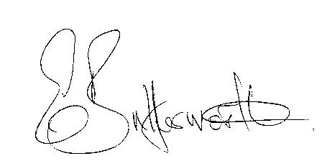Clerk

