Parish of Wilmcote

NOTICE OF MEETING OF

PARISH COUNCIL

NOTICE IS HEREBY GIVEN THAT -
A Meeting of the Parish Council for the above named Parish will be held at
Wilmcote Village Hall on the 21st May 2014 at 7.30 p.m.

Dated this 16th day of May 2014

Signed:
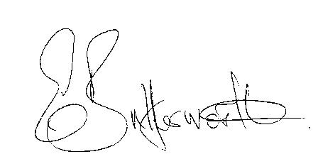Clerk

BUSINESS TO BE TRANSACTED

- Record of Members Present.

- To receive apologies and approve reasons for absence.

- To receive written requests for Disclosable Pecuniary Interests where that interest is not already in the register of members’ interests.

- To approve for signature the Minutes of the Annual Parish Meeting and ordinary Parish Council meeting on 19TH March 2014.

- Public participation.

- District and County Councillor reports. For information only. Unless known in advance items raised for a decision will appear on the next agenda.

- Planning Applications – status of current planning applications.

- Progress reports - for information only and items not on the agenda.

- Correspondence received:

- Coventry and Warwickshire Permit Scheme for Works on the Highway.
- Local Electoral arrangements finalised for Stratford on Avon District council.
- Consultation on a draft transparency code for Parish and Town Councils with a turnover not exceeding £25,000.
- Arrangements for dealing with complaints of Councillor misconduct

- Annual Accounts of Wilmcote Parish Council for 2013/14.

- Consultation: Local Government Boundary Commission – Electoral Review of
Warwickshire.

- Willow Wood Play Area: Report on site meeting attended by Cllr. K. McMillan, Cllr. Ray, Gary Compton and the Clerk.

- Stratford on Avon Draft Core Strategy: update.

- Reports received from residents as follows:
Aggressive printed note left under the windscreen wiper of vehicle parked in Station Road layby.
Footpath at rear of Aston Cantlow Road, adjacent to Marsh Road, being blocked by resident.
New surface laid to driveway of 65 Aston Cantlow Road.
The Stables, Featherbed Lane: Now advertised as a Riding Centre.

- Review of financial regulations – updated model.

- Pensions: Staff Pensions Legal Topic Note 79.

- Website update.

- Neighbourhood Plan report.

- Payment of outstanding invoices.

- Councillors’ reports and items for the agenda for the next meeting.

- Date of next meeting: 21st May 2014 – A.G.M. followed by ordinary meeting.

