NOTICE OF EXTRAORDINARY MEETING
OF WILMCOTE PARISH COUNCIL

A meeting of the Parish Council will be held in Wilmcote Village Hall on the 28th February 2024 at 7.00 p.m.

BUSINESS TO BE TRANSACTED

- Present.

- Apologies for absence.

- Declarations of interests in items on the agenda.

- Public representation. A written representation had been received from the applicants prior to the meeting.

- To consider and agree a response to Planning application Nos. 24/00149/LBC and 24/00148/FUL Masons Arms, Aston Cantlow Road, Wilmcote.

Dated this 23rd day of February 2024
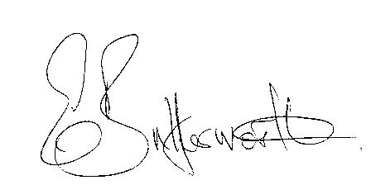Clerk

