NOTICE OF SPECIAL MEETING
OF PARISH COUNCIL

NOTICE IS HEREBY GIVEN THAT -
A Meeting the Parish Council has been convened for the above named Parish
on the 3rd August 2016 at 8.00p.m.
at Wilmcote Village Hall

BUSINESS TO BE TRANSACTED

- Apologies for absence.

- To receive written requests for Disclosable Pecuniary Interests where that interest is not already in the register of members’ interests.

- To consider quotation from Playdale Playgrounds Ltd. for replacement swings for the Willow Wood Play Area.

4. To consider Planning Application No. 16/02290/FUL Little
Longfields, 133 Aston Cantlow Road, Wilmcote: Alterations to the
external appearance of the dwelling to include the addition of a
window, flue and dormer to the front elevation, enlarged side
extension, addition of a porch, removal of front facing bay
windows and alterations and single storey extension to the rear.

Dated this 27th day of July 2016
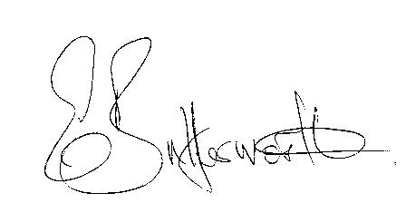Clerk

