NOTICE OF SPECIAL MEETING
OF PARISH COUNCIL

NOTICE IS HEREBY GIVEN THAT -
A Meeting the Parish Council has been convened for the above named Parish
on the 14th June 2016 at 7.30 p.m.
at Wilmcote Village Hall

BUSINESS TO BE TRANSACTED

- Apologies for absence.

- To consider Planning Application No. 16/01469/OUT Orchard Rise, 10 Manor Drive, Wilmcote. Outline application (all matters reserved except for access) for the construction of one dwelling.
PLANNING APPLICATION WITHDRAWN

4. Neighbourhood Plan update.

Dated this 8th day of June 2016
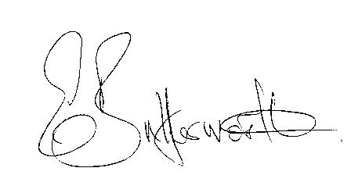Clerk

