NOTICE OF SPECIAL MEETING
OF PARISH COUNCIL

NOTICE IS HEREBY GIVEN THAT -

A Meeting the Parish Council has been convened for the above named Parish
on the 14th October 2015 at 8.00 p.m.
at Wilmcote Village Hall

BUSINESS TO BE TRANSACTED

- Apologies for absence.

- Declarations of dispensations granted for Disclosable Pecuniary Interests already in the register of Members Interests.

- To receive written requests for dispensations for Disclosable Pecuniary interests.

- Willow Wood Play Area: To consider advice from the Playground Inspector, following a site meeting, and to determine appropriate action.

Dated this 9th day of October 2015
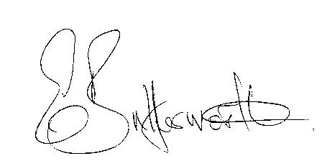Clerk

