NOTICE OF SPECIAL MEETING
OF PARISH COUNCIL

NOTICE IS HEREBY GIVEN THAT -
A Meeting the Parish Council has been convened for the above named Parish
on the 17th February 2016 at 8.00 p.m.
at Wilmcote Village Hall

BUSINESS TO BE TRANSACTED

- Apologies for absence.

- Declarations of dispensations granted for Disclosable Pecuniary Interests already in the register of Members Interests.

- To consider Planning Application No. 16/00361/OUT Arden View, The Orchard, Wilmcote:
Outline application (all matters reserved except for access) for the
erection of up to 4 residential dwellings and associated works
including demolition of part of single storey garage forming part of
Arden View (no. 2 The Orchard).

4. Neighbourhood Plan update.

Dated this 11th day of February 2016
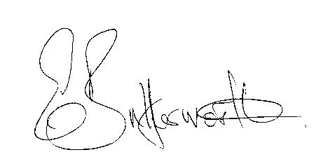Clerk

