NOTICE OF SPECIAL MEETING
OF PARISH COUNCIL

NOTICE IS HEREBY GIVEN THAT -
A Meeting the Parish Council has been convened for the above named Parish
on the 17th May 2017 at 7.00p.m.
at Wilmcote Village Hall

BUSINESS TO BE TRANSACTED

1. Record of attendees

2. Apologies for absence.
3. School Safety Zone: To improve road safety around the village school and church residents are invited to put forward their thoughts and suggestions to help us achieve this.

Dated this 11th day of May 2017
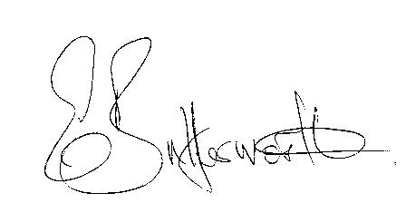Clerk

