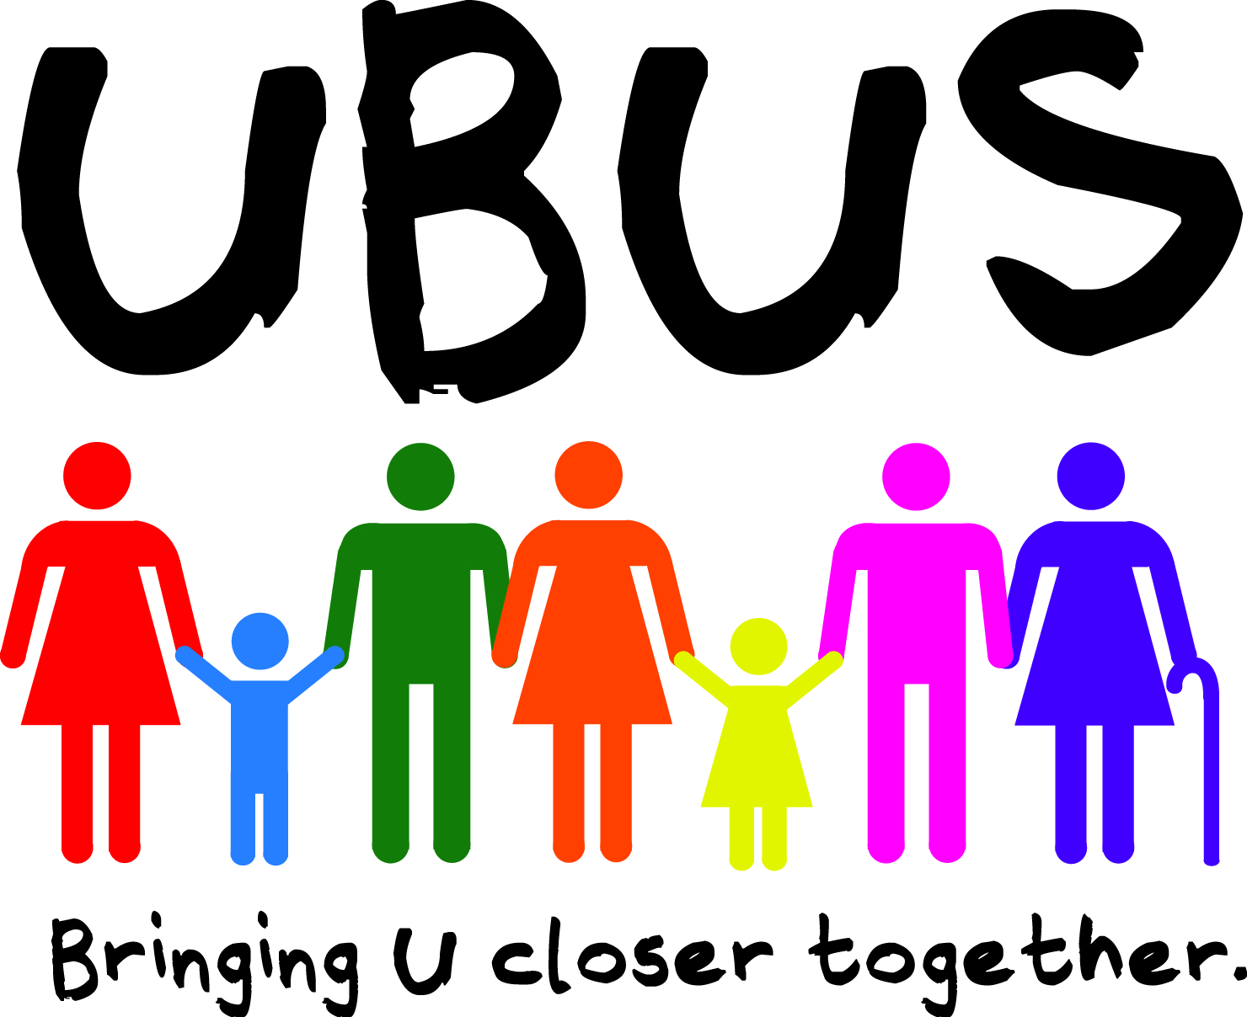**UBUS is 3 Years Old**

The UBUS community transport service has been running for 3 years now. Previously known as Community Links, UBUS came into effect in June 2014 and since then an amazing 30,000 journeys have been made across the district by over 800 registered users.

UBUS is a ring and ride community transport service operating within Stratford District.

UBUS is available to anyone in the district who struggles to access public transport due to mobility issues, health problems or who lives in an area with no, or infrequent, public transport.

Passengers can travel between 9:30am and 2:30pm.

UBUS will collect passengers from their door, drop them off at their destination, pick up again at the agreed point and drop off back at home. Drivers can assist passengers to get on & off the bus and will help with up to 3 shopping bags or a trolley if necessary.

All UBUS vehicles can accommodate a wheelchair.

Depending on where residents live in the district a single journey costs £2.10, £2.70 or £3.40. Return journeys £4.20, £5.40 or £6.80.

Residents living in an Orbit property are eligible for a £0.60 discount on their journey.

Journeys need to be booked in advance. Passengers can book up to seven days in advance.

UBUS provides transport in different parts of the district on specific days.

• West of Stratford - Operates on Mondays, Tuesdays, Wednesdays, Thursdays & Fridays

• East of Stratford – Operates on Mondays, Wednesdays & Fridays

• South of Stratford – Operates on Tuesdays, Wednesdays & Thursdays

• Stratford Town - Operates on Mondays to Fridays

• Southam & Surrounding area – Operates on Mondays, Tuesdays, Thursdays

UBUS can be used to visit friends, attend social groups, leisure activities or go shopping. It cannot be used to attend medical appointments.

**Residents interested in registering with the service should ring 01789 264491.**

**For further information contact Marie Darwen at Stratford District Council on 01789 260 108.**

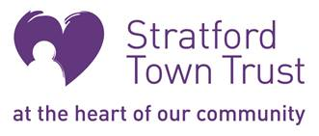UBUS is supported by Stratford District Council, Warwickshire County Council and Stratford Town Trust.

