Parish of Wilmcote

VACANCY IN THE OFFICE OF PARISH COUNCILLOR

NOTICE is hereby given, in accordance with Section 87(2) of the Local Government Act 1972 that a vacancy exists in the office of parish councillor for the parish of Wilmcote, by reason of the resignation of Councillor Fraser on 2nd November 2020.

Any ten local government electors for the parish may require an election to be held to fill the said vacancy. To do this, they must send a written request to the Chief Executive, Stratford-on-Avon District Council, Elizabeth House, Church Street, Stratford-upon-Avon, which must reach him not later than 15th December 2020. No set form of words is necessary.

If such a request is received by the Chief Executive, an election will be held. If no request is received, the vacancy will be filled in due course by co-option by the remaining members of the parish council.

Dated this 25th November 2020.

By order of the parish council

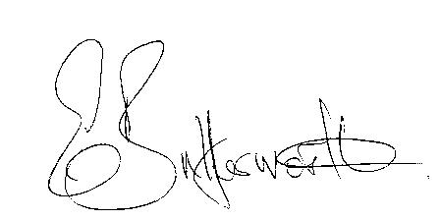

Parish Clerk

* Please note that due to the passing of emergency regulations in April 2020 governing the conduct of polls should an election be requested in respect of the above vacancy then it is unlikely a poll may be held before Thursday 6th May 2021.

