Community Road Safety

Are you adversely affected by traffic in Wilmcote and Pathlow?

Would you be interested in becoming part of a Community road safety awareness group?

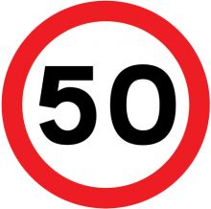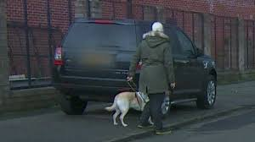

The Parish Council is looking for volunteers to evaluate traffic issues in the Parish, making recommendations to improve road safety.

If you are interested, please contact Liz Butterworth, Clerk to the Parish Council liz.butterworth1@btinternet.com / 01789 268998

