Wilmcote Area of Flood Risk

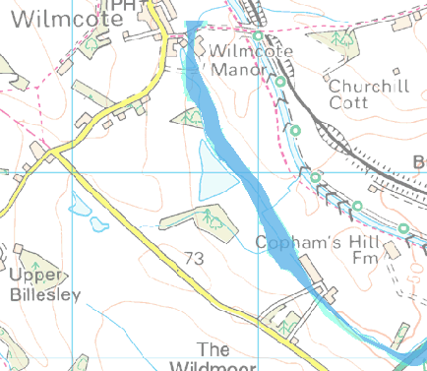

The Environment Agency provides advice on flood plains and the map above indicates their view of areas at risk.
Further information can be found on their website: www.environment-agency.gov.uk/floodrisk
Also the website www.checkmyfloodrisk.co.uk shows the level of risk.

