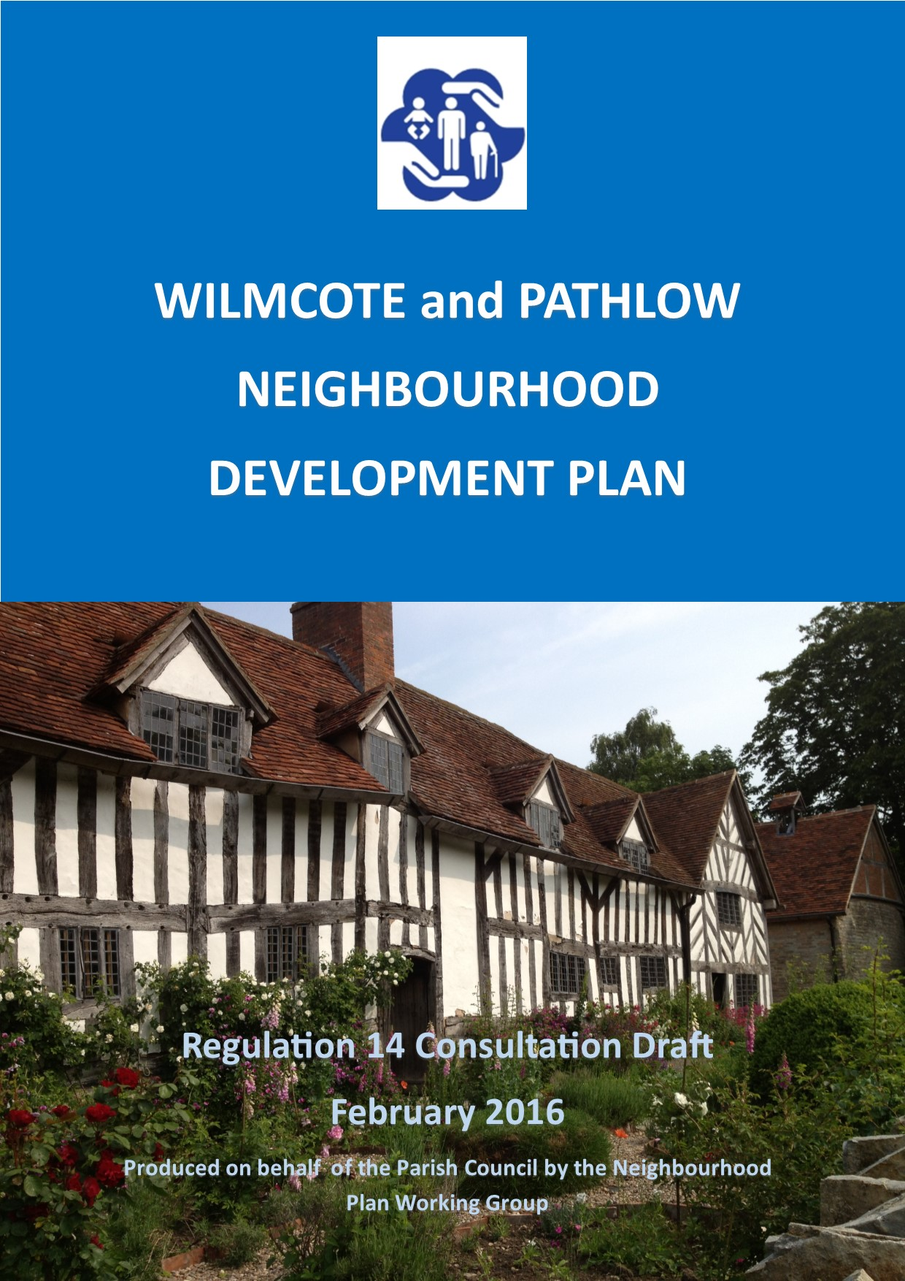

2031 Vision Statement

“Wilmcote and Pathlow is a strong and thriving community where history and heritage are protected and the rural setting and character are preserved and enhanced for current and future generations.”

CONTENTS

1. Introduction 6
2 Why is the Wilmcote Neighbourhood Development Plan (NDP) important? 10
3 The neighbourhood plan process 11
4 Community Consultation 13
5 Key Issues for the Wilmcote NDP 18
Key Issues Identified in the Community Consultations 18
Key Issues Identified from National and Strategic Planning Policy 19
6 Vision and Objectives 21
7 Wilmcote NDP Policies 22
OBJECTIVE 1 – To preserve and enhance local natural and built heritage assets 22
OBJECTIVE 2 – To protect and enhance the provision of community facilities 33
OBJECTIVE 3 – To manage future housing growth in Wilmcote, Pathlow and the wider parish 39
OBJECTIVE 4 – To promote good quality new buildings and to ensure suitable replacement, re-use and conversion of existing buildings 41
OBJECTIVE 5 – To promote leisure, recreation and tourism 43
OBJECTIVE 6 – To promote privacy, safety and security 44
8 Monitoring and Review 48
9 How to Comment on this Document 49

Appendix 1 - Wilmcote and Pathlow Neighbourhood Plan Community Communications 50
Appendix 2 - Glossary 55

LIST OF FIGURES

Figure 1: Wilmcote Neighbourhood Plan Area 8
Figure 2: Wilmcote Conservation Area 9
Figure 3. The Neighbourhood Plan Preparation Process 11
Figure 4. Consultation on the Wilmcote NDP 13
Figure 5. Green Belt in Stratford-on-Avon District Council 18
Figure 6. Protected Biodiversity Sites 24
Figure 7. Non-designated Heritage Assets 27
Figure 8. Prominent Public Views 32
Figure 9. Protected Community Facilities 34
Figure 10. Protected Local Green Spaces 36

1 Introduction

1.1 Welcome to the first formal consultation draft of the Wilmcote Neighbourhood Development Plan. This formal (Regulation 14) consultation draft has been prepared by a group of local volunteers and parish councillors and is being published to engage all those who live, work and carry out business in the area on the parish’s future development.
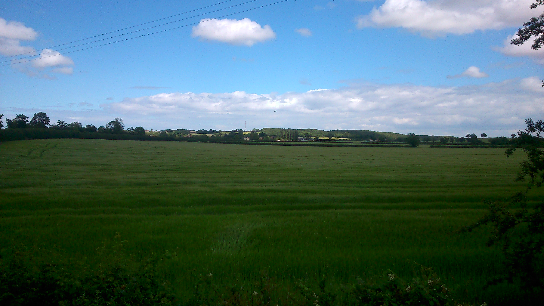
i View towards Pathlow from WIlmcote Station
1.2 Wilmcote is a rural village of unique historic significance, set within the open Warwickshire countryside. The parish of Wilmcote consists of the village of Wilmcote and the hamlet of Pathlow and their surrounding fields, with a population of 1,229 residents. It has a rich history, with both the village and hamlet appearing in The Domesday Book. Its most famous building, and a source of tourism and international interest, is Mary Arden’s House, originally the farm of William Shakespeare’s grandfather, Robert Arden, and the childhood home of his mother. The village attracts visitors from all over the world to this countryside museum and to its historic canal, which provides an important green corridor to Stratford-upon-Avon, rich in wildlife habitats. Farmland close to the canal and railway features vestiges of the local industry that flourished in the nineteenth century: the quarrying of Wilmcote stone, used for the floor of the Houses of Parliament. Today, the village is served by train and bus, has a primary school, a church, a village hall and youth centre, a social club, two pubs, a scout hut, a children’s play area, two playing fields, shop and mobile Post Office. The questionnaire conducted by the Neighbourhood Planning Group revealed that residents greatly value such amenities and recreational spaces, including the canal, and that they wish to protect the peacefulness of the village, its friendly community, its history, its Green Belt setting and views across open countryside, and the fact that it is not overdeveloped.
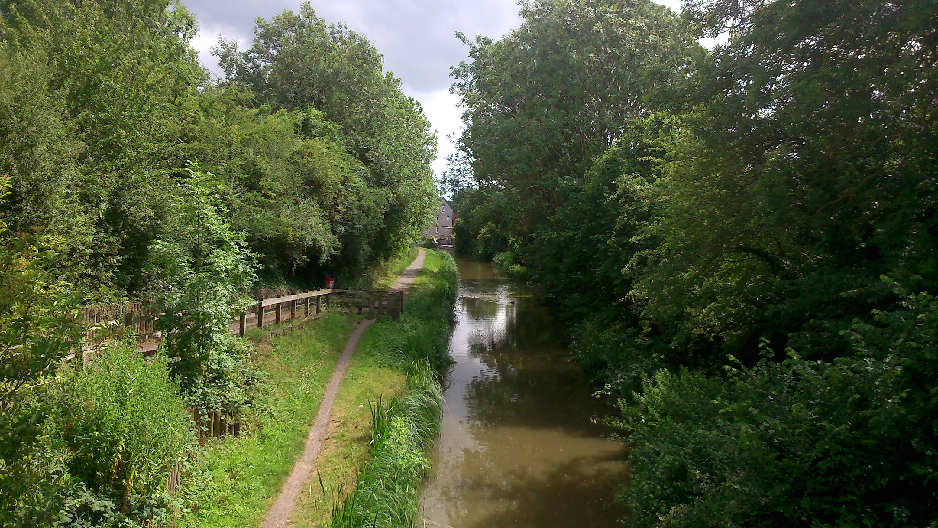
ii Stratford-upon-Avon Canal
1.3 The Localism Act 2011 introduced significant reforms to the planning system in England. These reforms gave local communities more say in shaping future development in their area. The most significant reform gave local parish councils the power to prepare a Neighbourhood Development Plan for their area.
1.4 Wilmcote Parish Council (WPC) presented this opportunity to residents at a public meeting held on 21st of October 2013, it was unanimously decided that it was essential to use this new power.
1.5 The Parish Council, therefore, applied to be designated a neighbourhood planning body for the whole parish. Wilmcote was approved as a neighbourhood planning area by Stratford-on-Avon District Council on 10th of February 2014. This designation has allowed the local community to come together, through the preparation of this Neighbourhood Development Plan, to set out how the future development of the area should be shaped up to 2031.
1.6 The Neighbourhood Development Plan will cover the area of the whole parish (Figure 1). This includes the village of Wilmcote, with its Conservation Area (Figure 2), the hamlet of Pathlow and the surrounding countryside.
Figure 1: Wilmcote Neighbourhood Plan Area
(© Crown copyright and database rights [2015] Ordnance Survey 100055940 Wilmcote Parish Council (Licensee) License number 100054743)
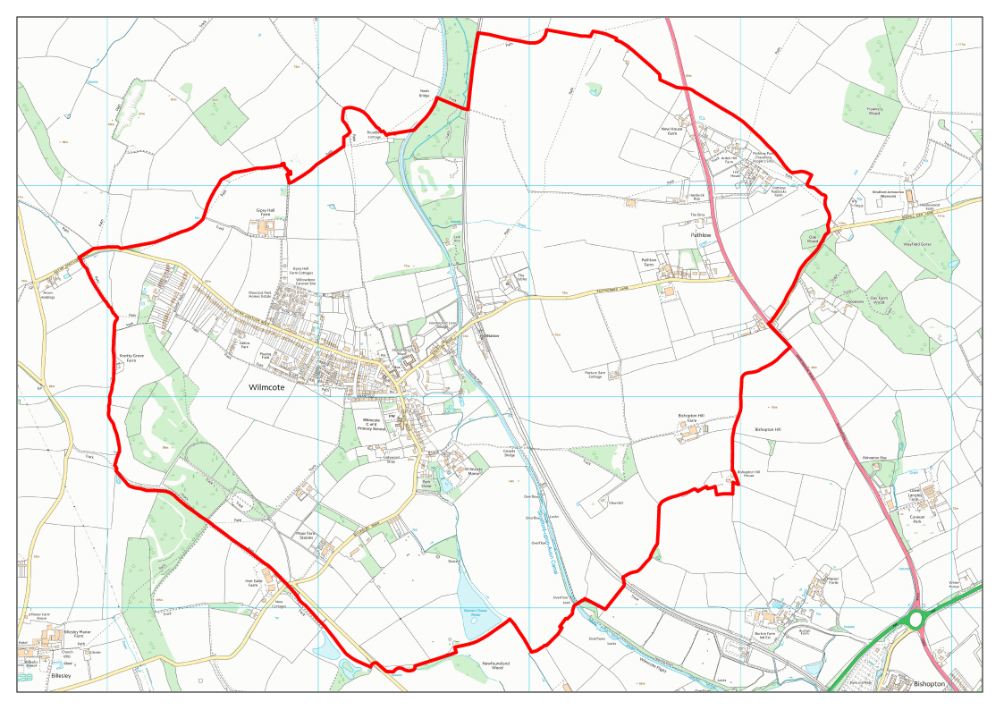

Figure 2: Wilmcote Conservation Area (Source: Stratford-on-Avon District Council)
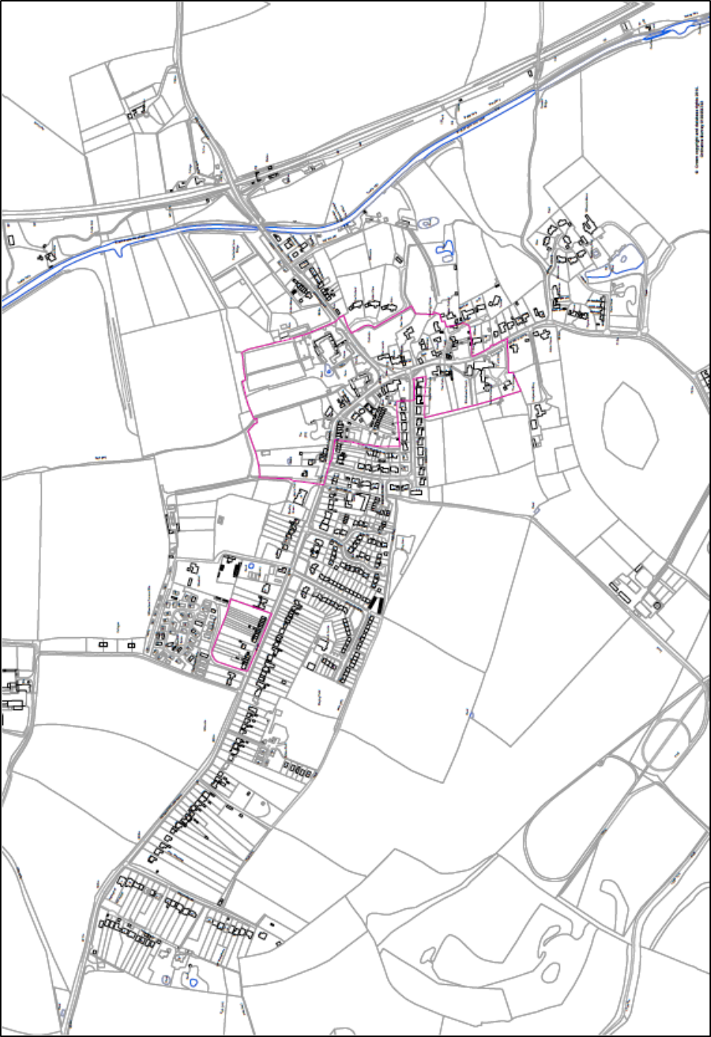

2 Why is the Wilmcote Neighbourhood Development Plan important?

2.1 The Wilmcote Neighbourhood Development Plan (NDP for short) is a new type of development plan. Introduced by the Localism Act in 2011, NDPs give local communities, through their parish councils, the right to prepare a plan for their neighbourhood.
2.2 The significance of this is that when the Wilmcote NDP is finally “made” it will become part of the development plan for the area. This means planning applications in the parish, unless there are other material considerations, will normally be determined in accordance with the Wilmcote NDP and any relevant planning policies of Stratford-on-Avon District Council.

3 The neighbourhood plan process

3.1 The Wilmcote NDP must be prepared following a procedure set down by government (Figure 3). We have now published the Wilmcote NDP for a period of formal consultation from 1st of March 2016 to 12th of April 2016. After this we will consider any representations made, revise the plan where necessary, and then submit the plan to Stratford-on-Avon District Council in summer 2016. We hope to complete the process with a referendum in late 2016.

Figure 3. The Neighbourhood Plan Preparation Process

3.2 The neighbourhood plan preparation process includes a number of stages during which we must ensure we consult all those who live, work and carry out business in the area.
3.3 After these consultations the plan will be sent for examination by an independent expert. This examiner will be jointly appointed by the Parish Council and Stratford-on-Avon District Council.
3.4 At the examination, the examiner will assess whether the plan meets a set of basic conditions set out in relevant legislation. This is something all neighbourhood plans must comply with if they are to be formally made part of the development plan system. The basic conditions are:
- Does the Wilmcote NDP contribute to the achievement of sustainable development?
- Is the Wilmcote NDP in line with national planning policy and guidance?
- Is the Wilmcote NDP in general conformity with the strategic planning policies contained in the development plan for the area?
- Is the plan compatible with, and does not breach, European Union obligations?
3.5 If the examiner decides the answer to these questions is “yes” the Wilmcote NDP will be subject to a local referendum. The referendum will give all eligible voters on the electoral register in the parish the opportunity to vote and decide if the Wilmcote NDP should in future be used to help determine planning applications.
3.6 If the plan goes forward to referendum and more than 50% of those voting vote in favour of the plan then it is “made” part of the development plan by Stratford-on-Avon District Council. By becoming part of the development plan for the area, the plan becomes a statutory consideration in guiding future development and will be used to help determine future planning applications in the area.

4 Community Consultation

4.1 This draft plan has been prepared following a significant amount of consultation with local people and others.
4.2 This has included a number of open public meetings, leaflets and a questionnaire. Figure 4 sets these out in more detail. A full list of activity can be found in Appendix 1.
Figure 4. Consultation on the Wilmcote NDP

4.3 A comprehensive set of neighbourhood planning pages on the Parish Council web site is also devoted to the Wilmcote NDP. We are also on Facebook.
4.4 The neighbourhood plan questionnaire survey was delivered to 513 households. The parish was split into 18 separate areas and members of the Steering Group and the Parish Council took on the responsibility to ensure each household was visited and given a questionnaire. In total, 351 questionnaires were completed for an overall response rate of 73%. All of the 18 separate areas had responses over 50%. Only 1 response was received from the Travellers’ site.
4.5 A full set of results from the survey can be seen in the accompanying survey report, but, in summary, the survey revealed the following:
Housing
- 85% of respondents agreed with “Limited Infilling” when asked what form future proposed housing should take. 79% agreed that there should be “Limited Affordable Housing” for local community needs and 78% felt there should be redevelopment of previously developed sites.
- 33% of respondents stated 2015-2020 when asked their views on the rate at which development of new properties should take place; 30% felt development should take place between 2021 and 2025; and 37% between 2026 and 2031.
- When asked whether building the allocated number of new dwellings sooner would support local facilities, 68% said no as they do not want houses built at a quicker rate.
- Respondents were asked if they would like to see more than 75 new dwellings built in the period 2011-2031 and 91% stated no.
- When asked what size of individual developments they would prefer, 54% of respondents stated 1-5 dwellings, 44% wished for 6 to 10 new dwellings and 23% 11-15 new dwellings. More than one option could be ticked.
- 78% of respondents stated that they would prefer 35% of new housing to be affordable.

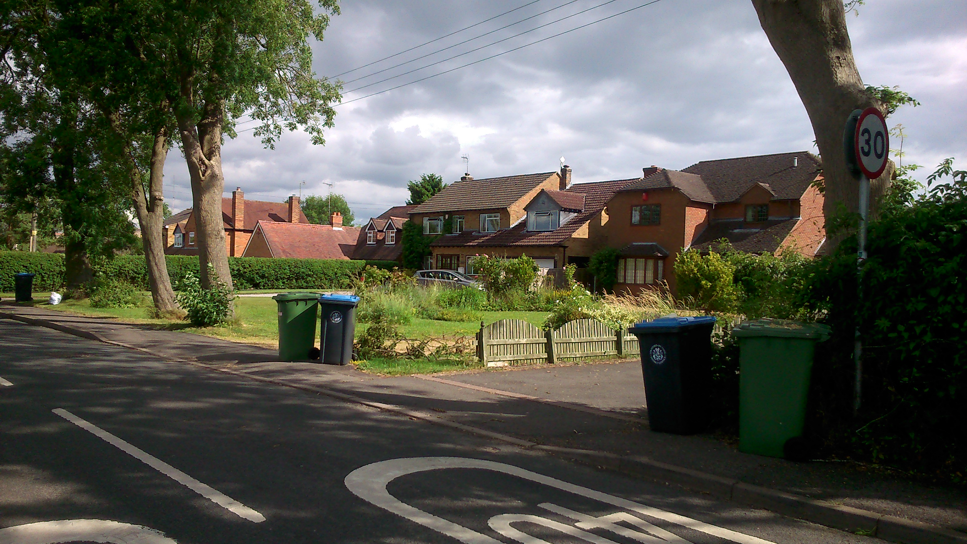
iii Wilmcote has a wide mix of house types and styles

- When asked what mix of properties residents would like to see in Wilmcote, 36% stated 3 bedroom houses, 27% two bedroom houses and 23% four bedroom homes. One bedroom flats were the least desirable at 13%.
- Almost six in ten (57%) stated new dwellings should be for children of parents in the village with 41% saying they should be for the elderly. 38% stated no preference - the mix should be driven by market needs.
- When asked if respondents would support single dwellings being built as infill or on garden sites, 58% stated they would support this practice.
- 83% of those surveyed would support the conversion or replacement of barns or buildings not currently used for housing as new dwellings.
- Respondents were asked whether they supported the demolition of a larger house and its replacement by one or more smaller dwellings, 9% were fully supportive, 36% supportive whilst 20% were against and 12% totally against.
- 63% stated that they would not be interested in self-build housing compared to 20% who are interested and 17% who did not know.
- Just under half of respondents (45%) stated that they believe it is important to build affordable houses, with only 6% stating that it is not at all important.
- When asked the importance of providing social housing in Wilmcote & Pathlow, 42% of respondents stated that it is very important or important, compared to 30% who said it was unimportant/not at all important.
- When asked what appropriate social housing is needed for Wilmcote & Pathlow, 52% stated rented property compared to the 84% who went for shared ownership.
- 92% stated no when asked if someone in your household or an individual family member might be looking for social housing in Wilmcote and Pathlow in the next 20 years.
- When asked how many bedrooms would be required were a family member to be looking for a home in Wilmcote in the next 20 years - six in ten (57%) stated two bedrooms, with one and three bedrooms both receiving a score of 22%.
- When asked if there should be a minimum distance from the front or rear of an existing dwelling to the building line of a new building or row of buildings, 85% of respondents stated yes.
- Of those saying yes about a minimum distance, 40% felt it should be 10 metres or under, 30% felt it should be between 10 and 20 metres, with 13% preferring 21 to 30 metres.
- Asked if all new dwellings should have on-site parking for two cars, exactly nine in ten respondents stated they should.
- When asked whether garden size is important in new housing developments, over three quarters (76%) stated it is.
- For those who felt garden sizes were important, these respondents were asked what their preferred minimum length for a garden was. 62% of respondents stated 10-20 metres; compared to the 17% saying over 20 metres and 21% felt it should be about 10 metres.
- Respondents were asked if they would support another travellers’ site in the Parish: 98% stated no.
- 83% of respondents stated that they would not support an increase in the existing traveller’s site in Pathlow.
- 54% would support an increase in the number of dwellings of the three park home sites at Woodcot Park, Willowdene or Edkins Park.
- When respondents were shown a statement with criteria about what made for good housing design, 93% supported the statement, with only 7% saying no.
- 99% of respondents agreed that privacy, security and safety are very important with no one stating that it is unimportant.
Non-Housing
- When asked the importance of protecting the features of Wilmcote and Pathlow, privacy, security and safety were the most important (99%). This was followed by historic buildings and their surroundings (92%), next were open views across the countryside (86%), open views when approaching and leaving the village (75%), and front gardens for new dwellings (64%).
- The amenities that were thought to be the most essential were the shop (70%) and the School (56%).

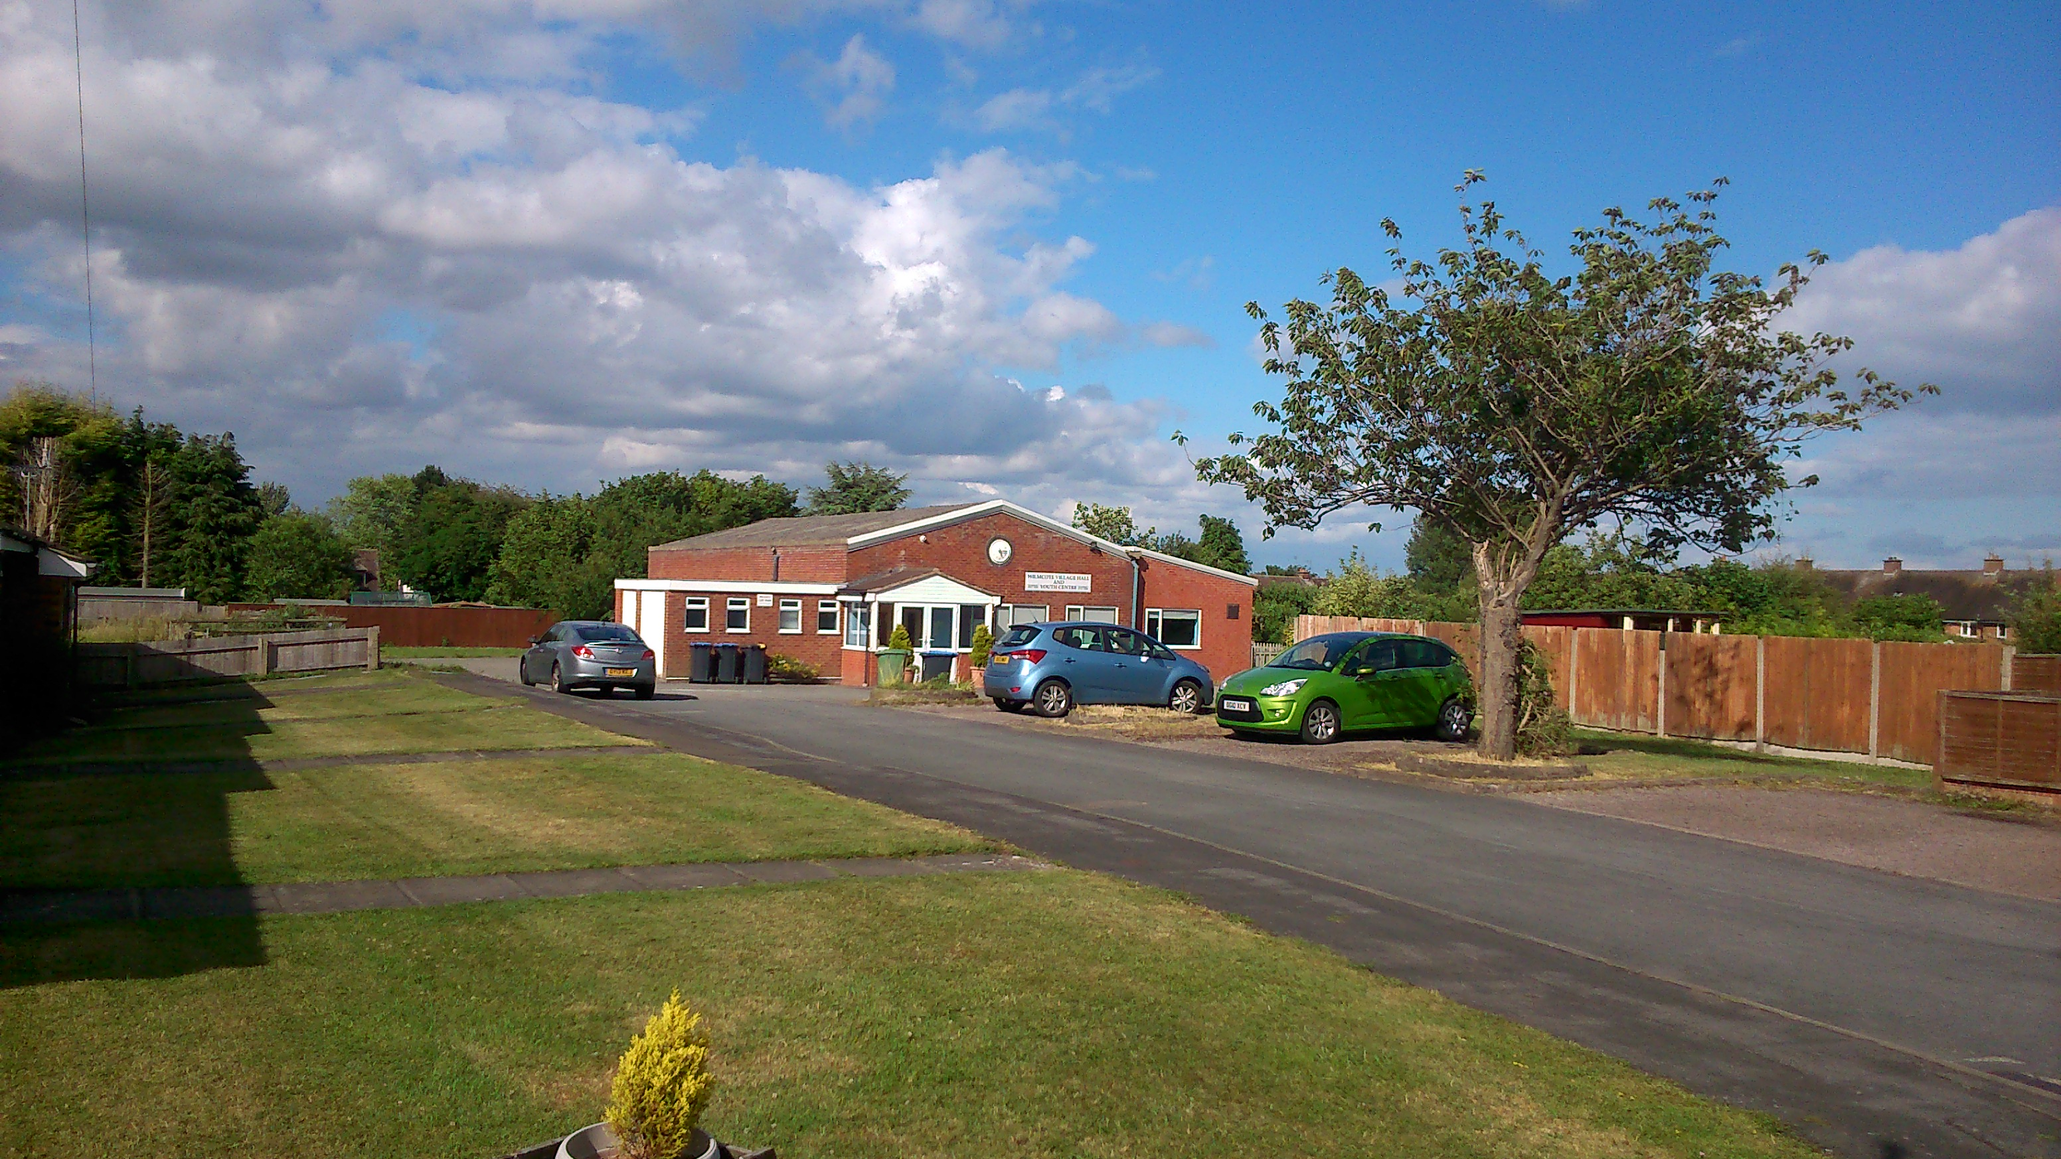
iv Village Hall and Youth Centre
- The amenities deemed to be not so important were the Social Club (35%), the Scout Hut (33%) and the Village Church (24%).
- 98% of respondents stated that they would be happy to take action to retain a shop somewhere in the community, if there was a likelihood of losing the existing shop.
- Nine in ten respondents (88%) said that they do not run a company or practice/service from their premises or home in the parish.
- Effectively there was a 50/50 split over the support residents would give to a small business area within the Parish.
- Over three quarters (77%) stated that there is a problem with speeding through Wilmcote & Pathlow.
- When asked if respondents would support traffic calming measures in the parish, 70% responded yes.
- When asked if respondents consider sustainable development to be important within the context of housing, business, amenities and infrastructure, 66% stated yes.
- Three quarters of respondents (74%) agreed with not building new housing on rural land, compared with 13% who disagreed and 12% who had no strong view.
- Residents were asked where they wished to see future funding with parking for the station and canal the highest rated. This was followed by better bus services and parking for the school and church. The least important were the scout’s facilities and village furniture.
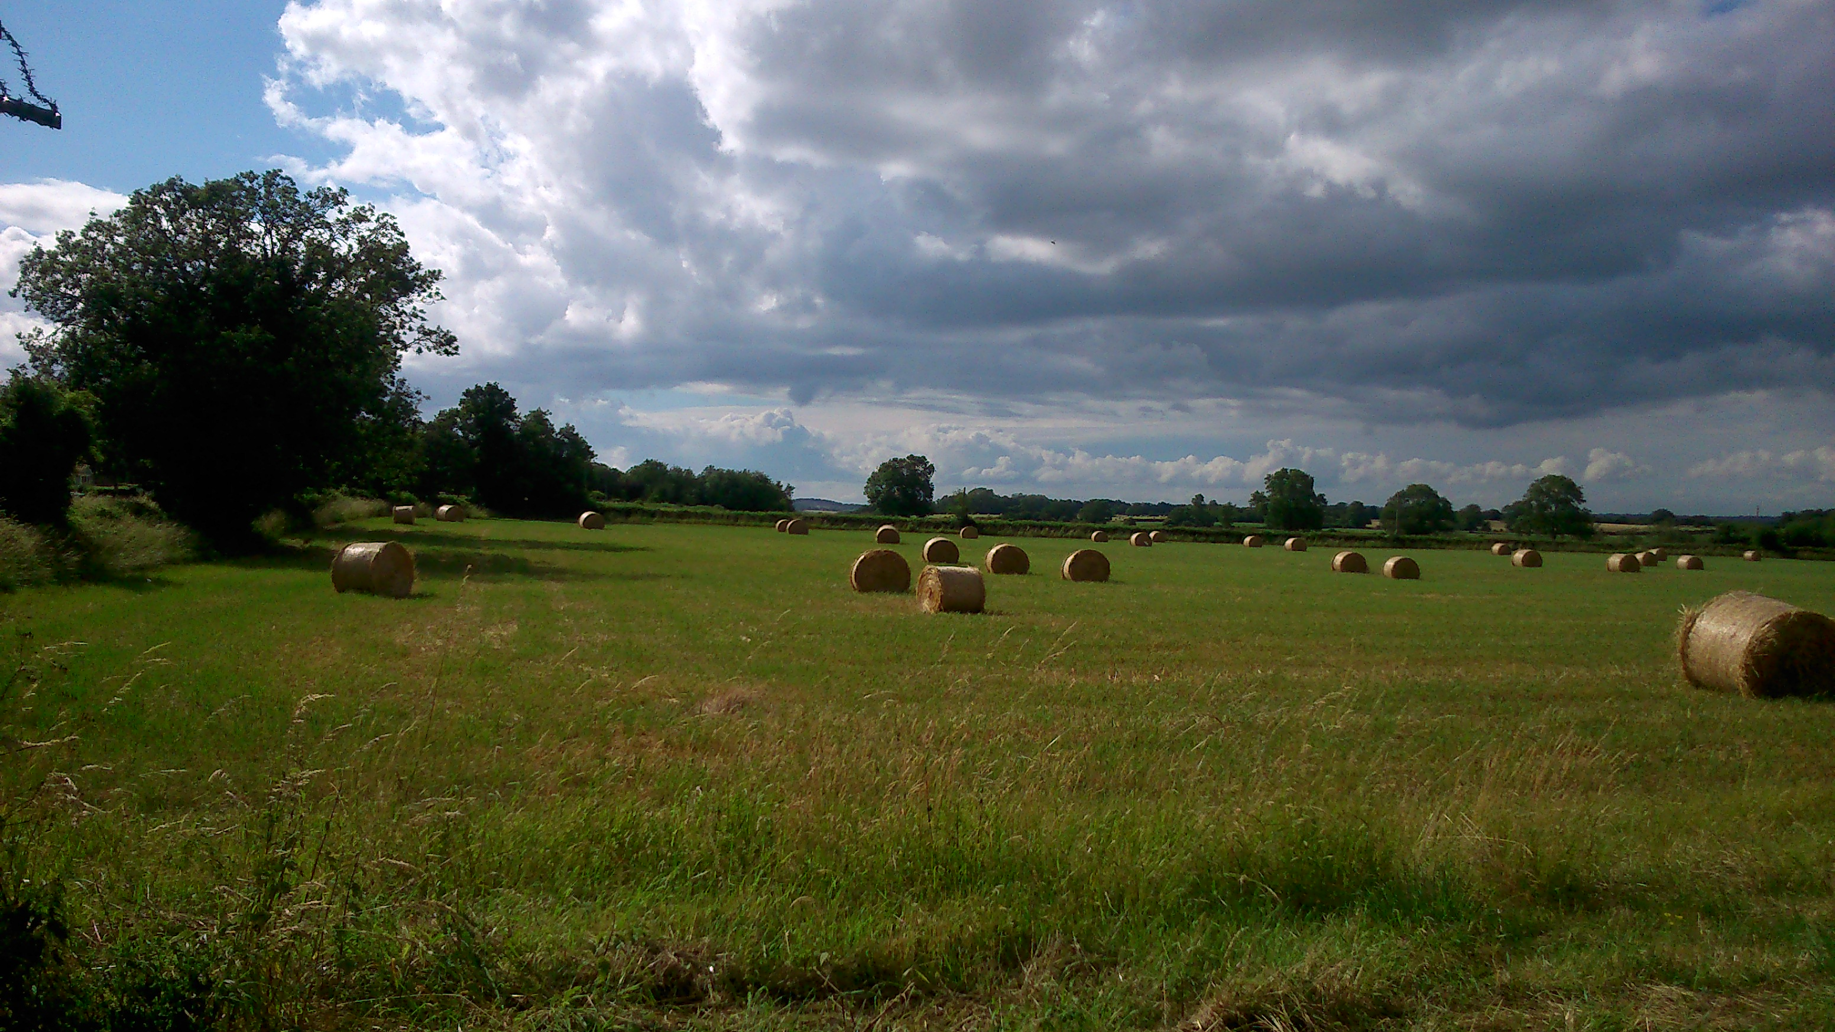
v Protect rural land – view from Aston Cantlow Road

5 Key Issues for the Wilmcote NDP

5.1 A number of key issues have been identified for the Wilmcote NDP to address. These issues have been identified during our early community consultations (including the questionnaire survey) and from the need to address issues raised by national planning policy and strategic planning policy set by Stratford-on-Avon District Council.

Key Issues Identified in the Community Consultations
5.2 From our community consultations and questionnaire we have identified the following key issues to be addressed by the Wilmcote NDP over the next 15 years.
Figure 5. Green Belt in Stratford-on-Avon District Council
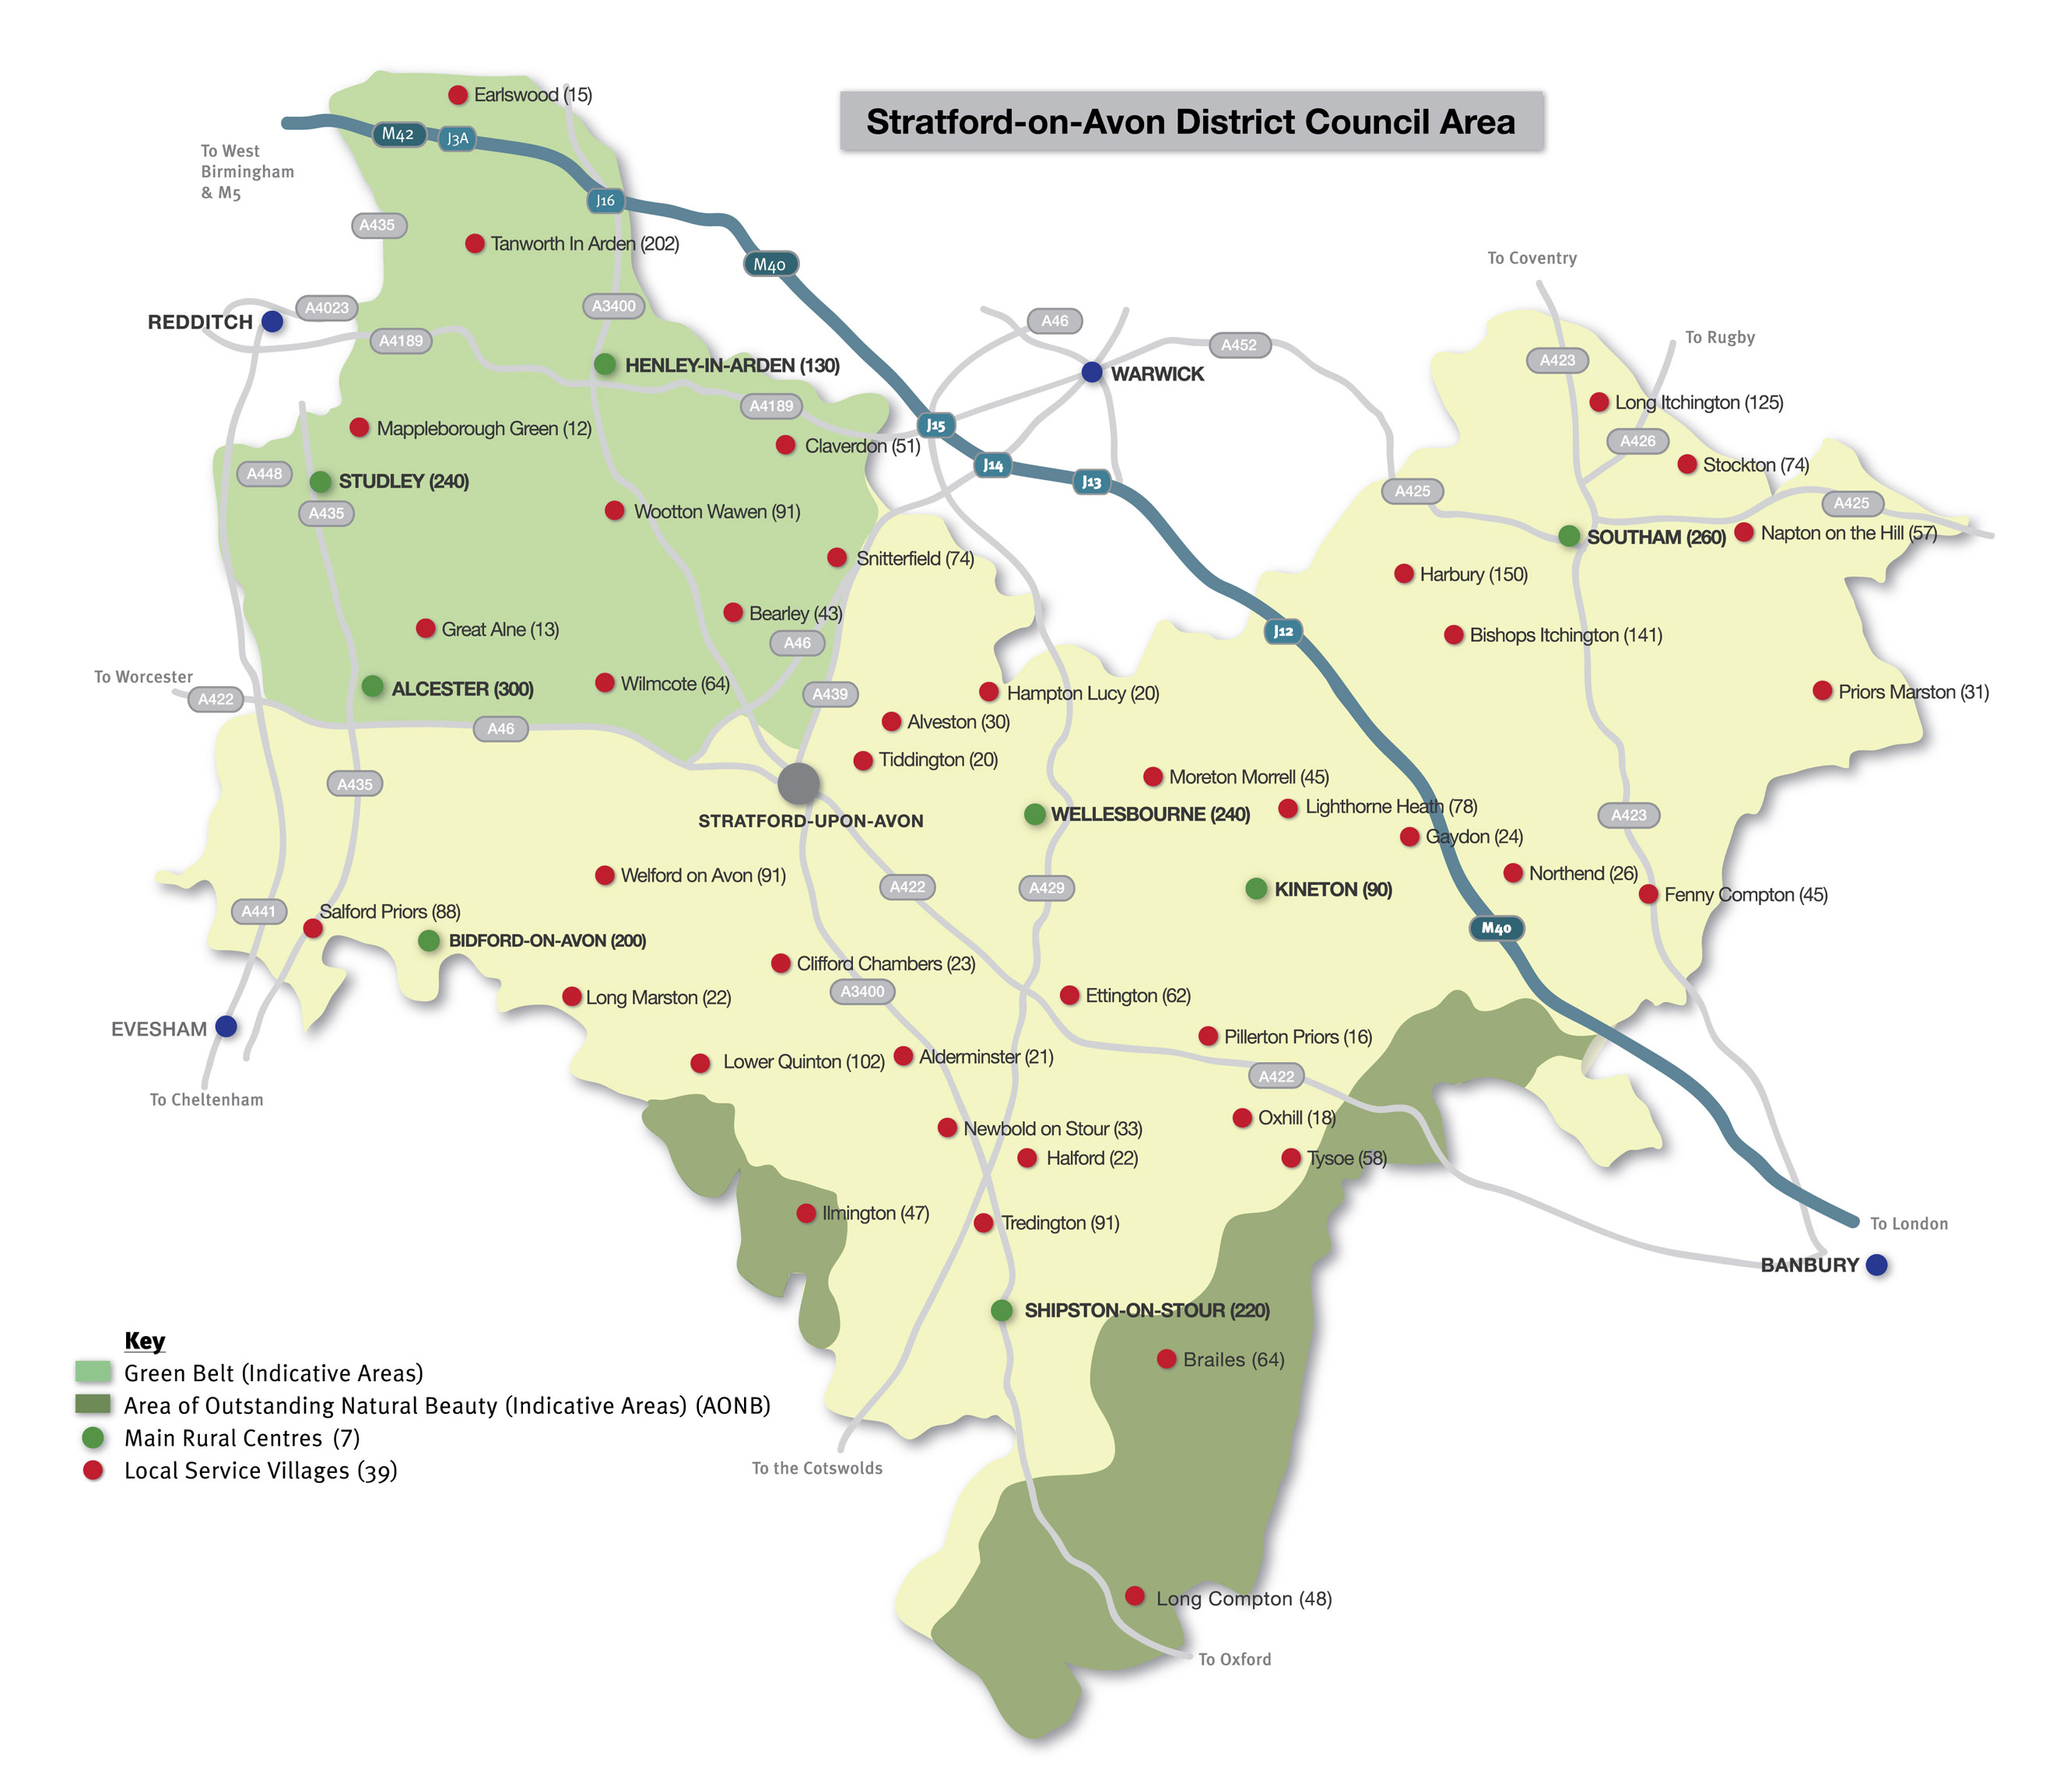
5.3 Housing presents arguably the biggest set of issues facing the parish over the next 15 years. From our survey, 85% of respondents said they would support further limited infilling in Wilmcote village and 74% of respondents felt there should be no housing development on rural, open land. As a village in the Arden area, north of the A46, Wilmcote is situated within a significant area of the West Midlands Green Belt between Stratford and Birmingham, see Figure 5.
5.4 Wilmcote is “washed over” by the Green Belt and existing planning policy at both national and strategic level will only permit limited infilling within the village; limited affordable housing for local community needs; and the partial or complete re-development of previously developed sites.
5.5 Wilmcote parish is also important for its Green Infrastructure. The community response to the questionnaire (summarised in the previous section), indicates the importance of protecting existing environmental assets including Wilmcote’s unique historic sites and their surroundings (92%), open views across the countryside (86%), and open views when approaching and leaving the village (75%).
5.6 Alongside the issue of how much housing growth there should be in Wilmcote village, a number of other housing issues were identified, including:
- Provision of affordable housing
- Mix of properties in terms of size of house and number of bedrooms
- Support for conversion of existing buildings to housing
- Replacement of existing dwellings
- On-site car parking for at least two cars
- Support for an increase in the number of dwellings at the three park homes sites
- Importance of quality of housing design
5.7 As well as housing, the community consultations highlighted a number of other issues:
- Car parking at the station and canal
- The importance of community assets such as the school and shop
- A problem with speeding traffic in the parish
- Strong support for protecting existing environmental assets including historic buildings and their surroundings and open views across the countryside

Key Issues Identified from National and Strategic Planning Policy
5.8 As well as the community consultations the Wilmcote NDP must be prepared by having appropriate regard to national planning policy and to be in general conformity with strategic planning policy as set out by Stratford-on-Avon District Council.
5.9 National planning policy is contained in one document, the National Planning Policy Framework (NPPF). The government have also published web based guidance alongside this in the National Planning Practice Guide (NPPG). The Wilmcote NDP has been prepared to take full account of both of these documents.
5.10 The key area of national planning policy affecting the Wilmcote NDP is national Green Belt policy. This sets out the strict controls on the type of development permitted in the Green Belt (paras. 88 and 89 of NPPF) and the circumstances when Green Belt boundaries can be changed (paras.82 and 83). With regard to the latter, Green Belt boundaries can only be altered in exceptional circumstances and through the preparation or review of a Local Plan. The preparation of the Local Plan for the area is the responsibility Stratford-on-Avon District Council. Currently, the emerging Local Plan (Core Strategy) is very unlikely to change Green Belt boundaries, and this means that the Wilmcote NDP must be prepared within the strict limits of existing national Green Belt policy: that when considering any planning application, local planning authorities should ensure that substantial weight is given to any harm to the Green Belt (NPPF, para. 88); and, with certain exceptions, the construction of new buildings in the Green Belt should be considered inappropriate (para 89).
5.11 But these limits offer opportunities in terms of infilling and other forms of building that are acceptable in Green Belt. These, and other positive and beneficial uses of the Green Belt, as identified in para. 81 of NPPF, including “opportunities to provide access; to provide opportunities for outdoor sport and recreation; to retain and enhance landscapes, visual amenity and biodiversity; or to improve damaged and derelict land”.
5.12 Existing planning policy for Stratford is contained in the Stratford-on-Avon District Council Local Plan Review (2006). This identifies Wilmcote as a Local Centre Village “washed over” by the Green Belt.
5.13 Emerging planning policy in the Stratford-on-Avon Core Strategy (Policy CS15) maintains this position with limited infilling continuing to be considered acceptable in Wilmcote in what will in future be termed a Local Service Village. Pathlow is defined as an “other settlement” under Policy CS15 of the emerging Core Strategy, and will, therefore, only be considered for small-scale, community-led housing development that meets a need identified by the local community and that is in line with national Green Belt policy.
5.14 The parish also has valued, natural heritage assets with many distinctive habitats, including the canal. The Stratford-upon-Avon Canal is identified as a sub-regional green infrastructure resource whose character and continuity should be maintained (Source: Warwickshire, Coventry and Solihull Sub - Regional Green Infrastructure Strategy November 2013). The canal and towpath are valued by residents: 92% of those responding named the canal as an important recreational amenity. The canal is also a potential Local Wildlife Site.
5.15 Wilmcote also has a significant number of designated and non-designated heritage assets. This includes the conservation area and three Grade I listed buildings and 16 Grade II. The parish also has a number of historic farmsteads. In addition, the Local History Society has identified several sites of historic interest related to the area’s quarrying and canal heritage.
5.16 The evidence base used to develop the neighbourhood plan is set out in full in the accompanying Planning Policy Assessment and Evidence Base report.

6 Vision and Objectives

6.1 Our Vision Statement for 2031 is that:
“Wilmcote and Pathlow is a strong and thriving community where history and heritage are protected and the rural setting and character are preserved and enhanced for current and future generations.”
6.2 In order for us to achieve this Vision and to address the key issues we have identified in chapter 5 of this plan we have identified the following key objectives for the Wilmcote NDP:
OBJECTIVE 1 – To preserve and enhance local natural and built heritage assets
OBJECTIVE 2 – To protect and enhance the provision of community facilities
OBJECTIVE 3 – To manage future housing growth in Wilmcote, Pathlow and the wider parish
OBJECTIVE 4 – To promote good quality new buildings and to ensure suitable replacement, re-use and conversion of existing buildings
OBJECTIVE 5 – To promote leisure, recreation and tourism
OBJECTIVE 6 – To promote privacy, safety and security

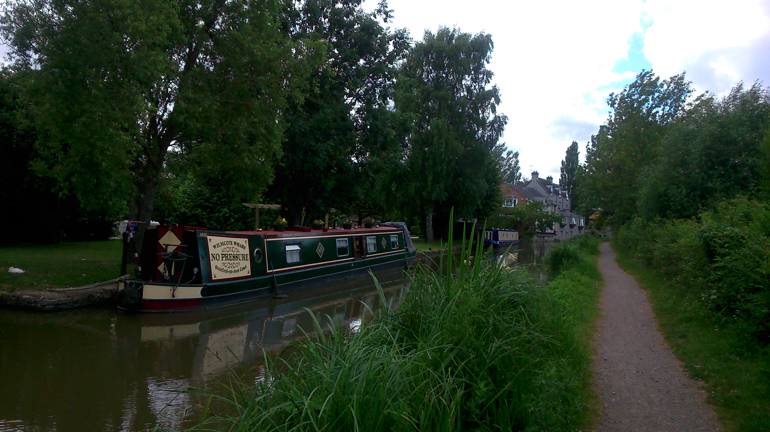
vi The canal is rich in history and wildlife and a leisure and recreation resource

7 Wilmcote NDP Policies

7.1 This section of the Wilmcote NDP contains the draft planning policies that we think should be used to manage, guide and promote future development in the parish up to 2031.
7.2 Each set of policies has been set out under the key objective that it will be used to help attain. Each policy is also followed by a “Background/Justification” that sets out, briefly, why the policy is considered to be necessary and how the policy will be used. Planning jargon can be difficult to understand and a glossary is included at Appendix 2.

OBJECTIVE 1 – To preserve and enhance local natural and built heritage assets
POLICY WP1 - BIODIVERSITY
All new development proposals should seek to minimise impact on and where possible secure net gains in biodiversity.
Proposed development within or outside the Copmill Hill Site of Special Scientific Interest (SSSI) (Figure 6) likely to have an adverse impact on the SSSI, either individually or in combination with other development, will not be supported. Where an adverse effect on the site’s notified special interest features is likely, an exception will only be made where the benefits of the development clearly outweigh both the impact on the features of the site that make it of special scientific interest and any broader impact on the national networks of SSSI’s.
Development resulting in significant harm to other ecological sites and priority habitats, including Local Wildlife Sites and Local Wildlife Potential Sites (Figure 6), and features such as semi-natural woodland, orchards, calcareous grasslands, ponds and streams and the canal, will not be supported. Where such harm cannot be avoided, applicants will have to demonstrate to the satisfaction of the local planning authority why the development cannot be located on an alternative site with less harmful impact and, if this has been successfully demonstrated, that adequate mitigation is put in place. As a last resort, suitable compensation within Wilmcote parish, must be agreed with the local planning authority.
Background/Justification
National planning policy seeks to contribute to the Government’s aim of halting the overall decline in biodiversity by using the planning system as a tool to minimise the impact on, and to secure net gains in biodiversity.
As part of Stratford-on-Avon District Council’s Core Strategy preparations, an “Ecological and Geological Study of Local Service Villages” was undertaken. In this Wilmcote, has an overall 50 per cent of habitat score for high distinctiveness. These include the SSSI Copmill Hill site and the Marsh Road and Hardwick Farm Meadows Local Wildlife Sites. In addition to these are the meadows around Mary Arden’s House museum site.
For the purposes of Policy WP1 potential Local Wildlife Areas are to be afforded the same status as confirmed Local Wildlife Areas until further investigation indicates otherwise.
Broad leaved and semi-natural woodlands are also a feature of the area and the main sites are to the south of Hardwick Farm Meadows, Mary Arden’s House museum and woods at Wilmcote Rough. The parish also has areas of semi-improved neutral grassland and semi-improved calcareous grassland, dense/continuous and scattered scrub, and standing water. Even areas that are not currently designated as Local Wildlife Sites (LWSs) can be significant ecologically. Thus, the ‘scattered scrub’ within the area known as the Bovis Triangle is rich in a variety of plants, including a species of yellow wort and wild carrot, among others, scoring ‘medium’ for habitat distinctiveness and ‘medium to high’ for connectivity, while the field behind St Andrew’s Church scores ‘high’ for habitat distinctiveness, as do the plots immediately west of the Canal Wharf.
The parish has a rich and diverse wildlife, including many protected species. Further details can be found in the Warwickshire County Council Green Infrastructure Strategy 2013 (access date 13.10.15).
The watercourses and water bodies, in particular the Stratford-upon-Avon Canal and Warren Chase Water, also contribute to the high distinctiveness scores.
Identified Local Wildlife Sites:
- Hardwick Meadows
- Wilmcote Pasture
- Marsh Road Meadow
The potential Local Wildlife Sites are:
- Stratford-upon-Avon Canal through Wilmcote
- Extension to Hardwick Meadows
- Warren Chase Water
- Wilmcote Rough (beginning at the end of Marsh Road)
- Caravan Park Field (Edkins Park)
- Caravan Park Field (Woodcote Park)
- Billesley Wood
- Pathlow field and verges on A3400
- Pathlow, South of Featherbed Lane, Wood by Churchill

Figure 6. Protected Biodiversity Sites (shown in bold outline: Red – SSSI; Green Local Wildlife Sites; Brown Potential Local Wildlife Sites)
(© Crown copyright and database rights [2015] Ordnance Survey 100055940 Wilmcote Parish Council (Licensee) License number 100054743)
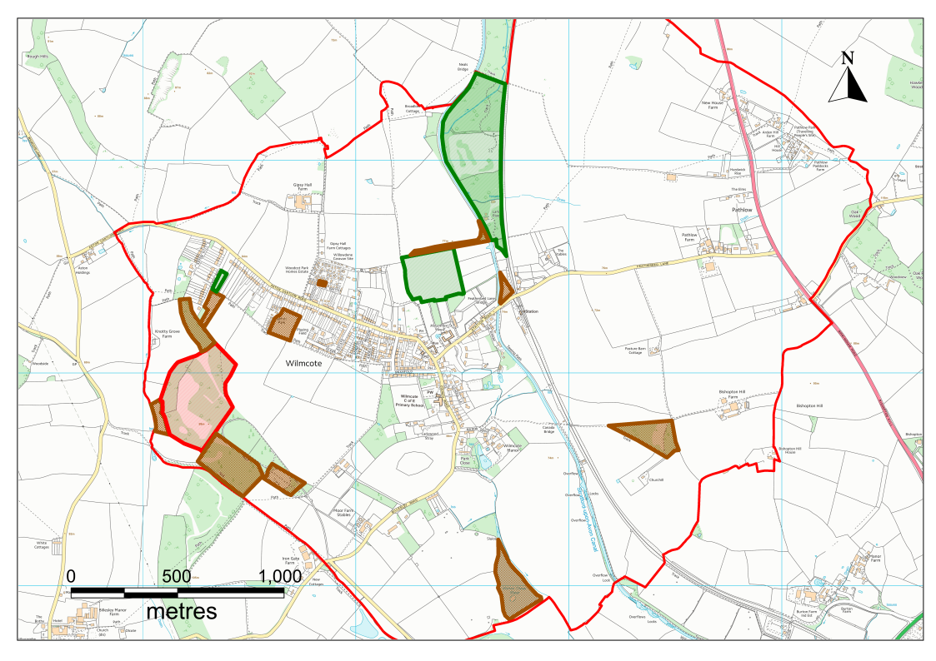
Based on advice from Natural England, the plan area includes a Biodiversity Action Plan Priority Habitat.
For further information on all of the above, visit the Warwickshire Habitat Biodiversity Audit. (access date 13.10.15)
POLICY WP2 - GEODIVERSITY
Development proposals should seek to preserve and enhance the parish’s natural geodiversity and the man-made legacy of quarrying and stone working. Particular regard should be had to soils and landforms and the late Triassic/early Jurassic geology of the parish.
Where development proposals affect areas with considerable potential for important palaeontological discoveries applicants may be required to undertake surveys of the natural geology, for the purposes of assessing the importance of a particular site, and where planning permission is to be granted, for the purposes of recording and sample collection.
Background/Justification
National planning policy seeks to minimise the impact on geodiversity – our soils, landforms, rocks, minerals and fossils. Wilmcote has much potential for important palaeontological discoveries due to the presence of the late Triassic – early Jurassic geology, in particular the Penarth Group and basal Blue Lias Formation, including the Wilmcote Limestone.
POLICY WP3 – NON-DESIGNATED HERITAGE ASSETS
The following local non-designated heritage assets (see Figure 7) identified by the Historic Environment Record and the community as having special local resonance should be conserved and enhanced:
- Blue Lias Lime and Cement Works located near canal (400m north of Featherbed Lane Bridge)
- Tramway on Gipsy Hall Farm land
- Wilmcote Quarry, 150m West of Wilmcote Football Ground, within Woodcote Mobile Home Park
- Lime Kilns, 500m north of Pathlow, also near the canal south of Featherbed Lane and 350m north of Church, between Canal and railroad
- Former Wilmcote Train Station (North of Featherbed Lane)
- Former Midlands railroad (section of Hatton-Honeybourne-Stratford Line
- Winding Hole, north of Featherbed Lane, Stratford-upon-Avon Canal
- Unlisted canal bridges, Stratford-upon-Avon Canal
- Round Barrow (Bronze Age) 500m East of Pathlow
- Hundred mound, 550m East of Pathlow
- Ridge and Furrow:
- Field at end of Aston Cantlow Road (West)
- Field North of Mary Arden’s Farm and East of Railroad
- Fields South of Mary Arden’s Farm, extending along canal
- Field Northwest of Pathlow
- Gipsy Hall Farm (Eighteenth Century Historic Farmstead)
- Hardwick Farm
- Moor Farm
- Medieval Turnpike Route - now the Birmingham Road and ancient road AD 1016 (Feldere Street)
Development proposals affecting these assets will be supported when they conserve and enhance these assets. Development that would result in the loss of, or have a detrimental impact on, these assets will only be supported in the following circumstances:
- Where renovation or alteration of non-designated heritage assets require planning permission, such changes are designed sensitively, and with careful regard to the heritage asset’s historical and architectural value and pay appropriate regard to the asset’s setting; or
- Where a development proposal would result in the loss of, or substantial harm to a locally non-designated heritage asset, such development will only be permitted when the public benefit of the proposed development outweighs the loss of or harm to the asset and its setting. Where development is permitted, this will be conditioned in such a way so as to ensure the development takes place after the loss, or harm, has occurred; and that appropriate recording of the heritage takes place prior to any loss or harm.
Background/Justification
National planning policy requires heritage assets to be conserved in a manner appropriate to their significance, so that they can be enjoyed for their contribution to the quality of life of this and future generations. Wilmcote’s Conservation Area (Figure 2) and statutory Listed Buildings already have existing protection under other legislation. However, our many and varied non-designated heritage assets also require a degree of protection so that they too can continue to make a contribution to the quality of life in the parish. Our survey results support this conclusion – when asked, 92% of respondents identified historic buildings and their surroundings as the most important feature in the local environment worthy of protection.
Wilmcote is entered in the Domesday Book (1086) where it is listed as part of the Pathlow ‘Hundred’. The Historic Environment Record for the area includes information on the historic landscape character of the area, including field formation, historic buildings and sites. Many features are no longer visible on the surface, such as the Bronze Age ‘Round Barrow’, as well as the mediaeval settlement of Wilmcote and its associated ‘ridge and furrow’ fields that are located to the south of the canal.

Figure 7. Non-designated Heritage Assets
(© Crown copyright and database rights [2015] Ordnance Survey 100055940 Wilmcote Parish Council (Licensee) License number 100054743)
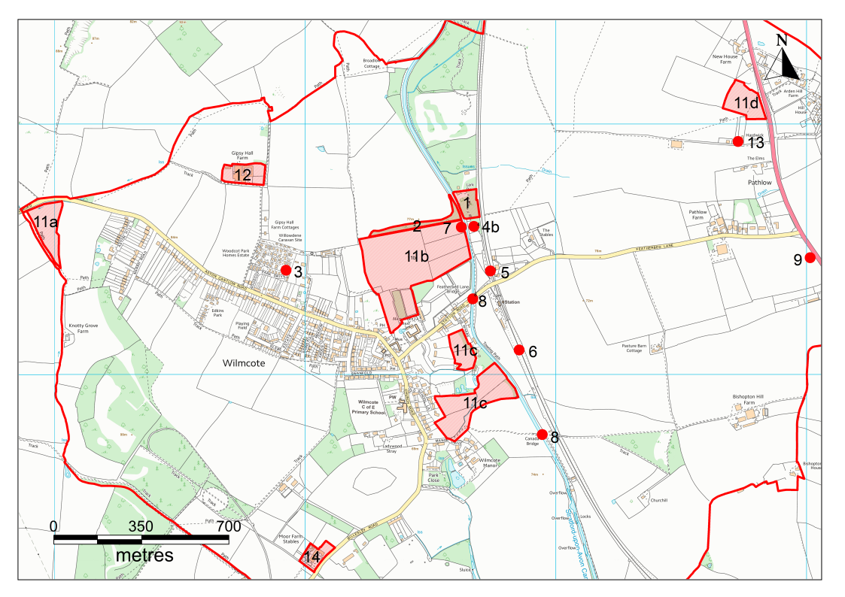

The earliest structures still standing are Mary Arden’s House, built during the 16th Century, Palmer’s Farm, Kirkside Cottage and Pear Tree Cottage, as well as the houses along Old School Lane. All of these are within the designated Conservation Area which also includes the 19th Century buildings that flourished with the industrial quarrying (the Masons Arms, the cottages belonging to the quarry workers, known as ‘The Tens’ and the ‘Eighteens’, made from the Blue Lias Wilmcote Stone, and the red-brick Congregational chapel), as well as Wilmcote School and Wilmcote Church. (For the Historic Environment Record entries on the nineteen listed buildings in Wilmcote click here).
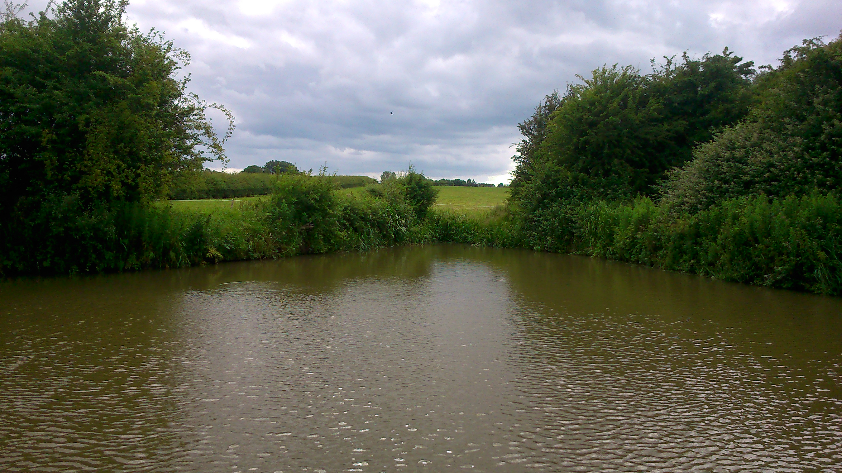
vii Winding Hole, historic site of termination of railway line and Blue Lias kiln beyond, Stratford-upon-Avon Canal
In addition, there are undesignated sites of historical interest, including the historic farmstead of 18th Century Gipsy Hall Farm, the location of the main Wilmcote Quarry (which is also a Site of Special Scientific Interest, or SSSI, for its Jurassic limestone fossils and vegetation) and also the site of a disused cement works, sawmill, and tramway that transported stone and lime to the railway and the canal, as well as some of the lime kilns in the area.
This plan seeks to safeguard these non-designated heritage assets, as well as those that may come to light during the lifetime of the plan.
Any non-designated heritage assets identified in the future and not listed under Policy WP3 may be added through future reviews of this plan. Some of the heritage assets identified under Policy WP3 may also may become part of community-backed projects. These will have the aim of highlighting (e.g. through signage, information boards) the sites for public interest. The Aston Cantlow Historical Society and Billesley Preservation Group has produced a leaflet, ‘Wilmcote, a Warwickshire Village’, which provides an account of the village’s history, and which has already helped to promote local knowledge of the historic environment.
In identifying the parish’s non-designated heritage assets, we have used the guidance published by Historic England in Knowing Your Place, and the Good Practice Guide for Local Heritage Listing.
POLICY WP4 – GREEN INFRASTRUCTURE
The network of paths, fields, watercourses and water features, woodland, grassland and other green infrastructure features within the parish should be maintained and enhanced for their recreational, tourism and ecological value. Development proposals should seek to maintain this green infrastructure network and, where possible, encourage the enhancement of the green infrastructure network by creating new connections and links in the network; restoring existing green infrastructure; or by introducing features that enhance the existing green infrastructure network.
Development that would disrupt or sever this network will not be permitted unless suitable compensatory provision can be provided to establish a new network connection within the immediate vicinity of the site.
Background/Justification
Green infrastructure is the network of paths, fields, watercourses, other water features, woodland, grassland and other similar features within the parish. This network is important for its leisure, recreation, tourism and ecological value.
The green infrastructure studies conducted in the area identify Wilmcote as having a high degree of “connectivity” arising from its green infrastructure network. This is due to area features and linear features, particularly the Stratford-upon-Avon Canal.
The village is part of the network of routes that are marked as ‘Leisure Drives’ for touring the unspoilt Warwickshire countryside. Some of the sights to be enjoyed in Wilmcote and in approaching the village feature the unique historic landscape: Mary Arden’s House and Palmer’s Farm, the Masons Arms and the stone cottages, and the distant view of Gipsy Hall Farm. Visitors and locals can enjoy both walking through the village or along its outskirts and refreshing themselves at the Masons Arms or The Mary Arden pub. Public rights of way are also valued (such as those leading alongside the fields to Billesley, behind the Glebe Estate up to Marsh Road, and from Aston Hill across to Gipsy Hall Farm and the Wilmcote Quarry). Other open spaces include the Village Green, and the Council-owned field in the Glebe Estate and the areas of green bordering the Glebe and the Aston Cantlow Road. Natural England and English Heritage also emphasise the importance of public ‘sight lines’ of green and open spaces for residents within a community, which Wilmcote amply furnishes along all its approaches to the village and in the ‘green fingers’ mentioned above that penetrate the village itself.
Developers will be encouraged to enhance the existing network of green infrastructure and to create new areas of green infrastructure or new links to existing green infrastructure networks. This policy has been prepared using the “Green Infrastructure Study for the Stratford-on-Avon District” (2011).
Up to date information on the green infrastructure network in Wilmcote can be found on Warwickshire County Council’s digital Green Infrastructure website (access date 13.10.15)
POLICY WP5 – LANDSCAPE CHARACTER
Development proposals will be required to incorporate the following landscape design principles:
- Height, scale, and form of buildings should not disrupt the visual amenities of the immediate surroundings or impact adversely on any significant wider landscape views;
- Development proposals should give careful consideration to noise, odour and light, which might be detrimental to the enjoyment of the area by other residents. Light pollution should be minimised wherever possible and security lighting should be appropriate, unobtrusive and energy efficient;
- Development proposals should conserve important local historic landscape features such as ridge and furrow fields, hedges and stone walls wherever possible. Woodland, orchards and small groups or individual mature and established trees should be protected and incorporated into landscaping schemes wherever possible; and
- New development should also take account of known surface and sub-surface archaeology, including preservation in situ and suitable recording and preservation off site. Where appropriate, applicants will be required to carry out an appropriate survey where there is potential for archaeological remains.
Background/Justification
National planning policy highlights how Green Belt designation offers the opportunity to retain and enhance landscapes and visual amenity. Policy WP5 identifies the key features in the local landscape to be retained and enhanced.
POLICY WP6 – PROMINENT PUBLIC VIEWS
The locally prominent views listed below and shown on Figure 8 are considered special and development will be required to take into consideration any adverse impacts on these views through landscape appraisals and impact studies.
- The Green
- Church of St Andrew
- Palmers Farm/Mary Arden’s House
- The Orchards
- Stratford-upon-Avon Canal
- Canal towpath towards Henley in Arden
- Canal towpath and cycleway towards Stratford-on-Avon
- View towards the Cotswold Hills from Featherbed Lane
- Featherbed Lane approach to Wilmcote, ahead is the Railway Bridge.
- Wilmcote Railway Station
- Featherbed Lane approach to Wilmcote, ahead is the canal bridge.
- View from Featherbed Lane across the field between the Railway Station and the canal
- View from the Railway Station footbridge towards the South-East.
- View to the rear of Mary Arden’s House
- Approach to the village along Aston Cantlow Road (part of the National Cycle Route 5) with open views to the North and North West across the historic farmstead of Gypsy Hall Farm and views beyond of the forested hills of Wootton Wawen
- Willow Wood Play Area
- Along Billesley Road looking towards the East
- Church Road approach to Wilmcote
- Billesley Road approach to Wilmcote
- Open countryside views from the Gallops to the South
- Open countryside views from the Gallops to the West
- View from Pathlow looking West towards Wilmcote village.
- View from Pathlow looking North-West towards the Railway Line and the canal
- View from Pathlow looking North-West towards the railway line. Wootton Hill can be seen in the distance
Background/Justification
Historic England’s “Knowing Your Place” emphasises the importance of views and lines of sight. They are an important aspect of local heritage, particularly when “valued by the community as a whole”.
The prominent public views listed in policy WP6 have been identified following a survey by the Neighbourhood Plan Steering Group.

Figure 8. Prominent Public Views (not to scale)
(© Crown copyright and database rights [2015] Ordnance Survey 100055940 Wilmcote Parish Council (Licensee) License number 100054743)
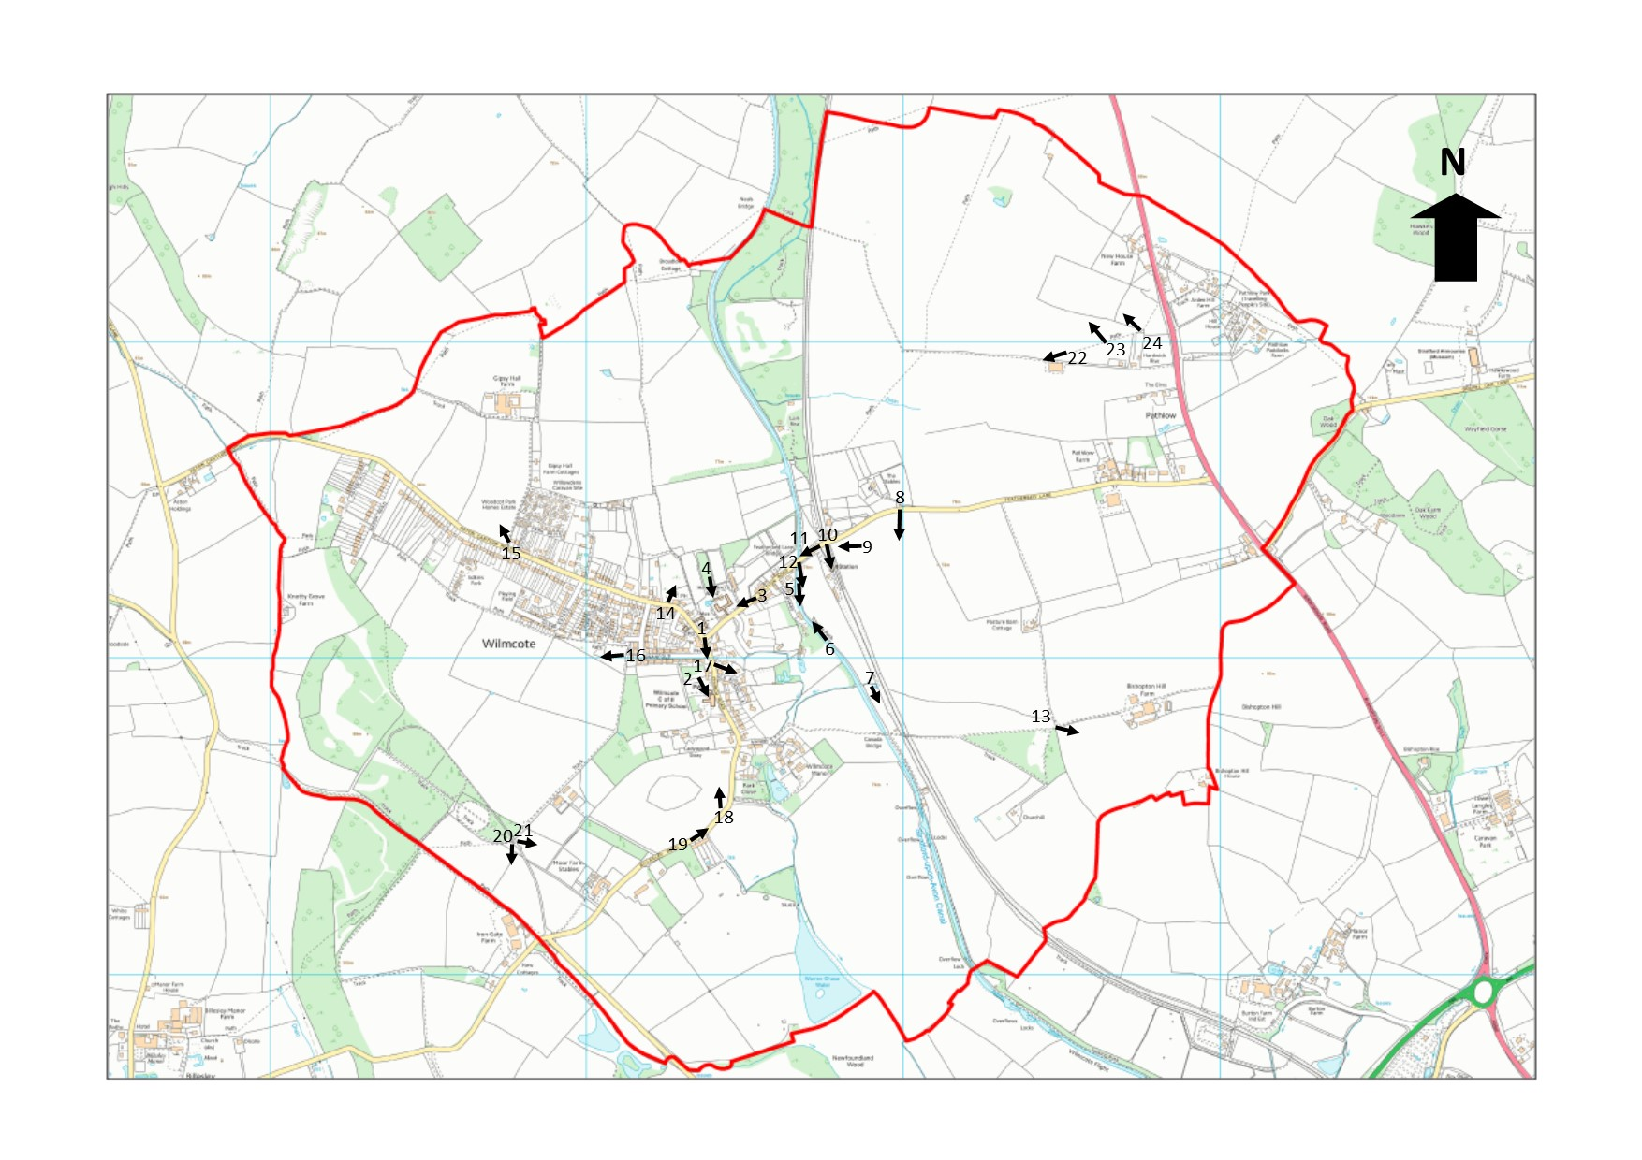

OBJECTIVE 2 – To protect and enhance the provision of community facilities
POLICY WP7 – PROTECTING AND ENHANCING COMMUNITY FACILITIES
The following community facilities (also shown on Figure 9) will be protected:
- St Andrews Church
- Wilmcote Post Office and Stores
- Mary Arden Inn
- Masons Arms
- Wilmcote Church of England Primary School
- Wilmcote Sports and Social Club
- Village Hall and Youth Centre
- Scout Hut

Development proposals for non-community uses of these buildings will only be permitted when the applicant can clearly demonstrate the building is no longer suited for future use as a community facility.

Development proposals to enhance or improve these facilities will be supported where they do not conflict with the purposes of the Green Belt or have an adverse impact on residential amenity.

Background/Justification
Wilmcote as a local service village has a modest range of community assets. These assets are part of the essential glue that helps create the strong community in the village. This policy seeks to retain these important assets. These include the local shop, two pubs, social club, village hall, scout hut and school.

Figure 9. Protected Community Facilities
(© Crown copyright and database rights [2015] Ordnance Survey 100055940 Wilmcote Parish Council (Licensee) License number 100054743)

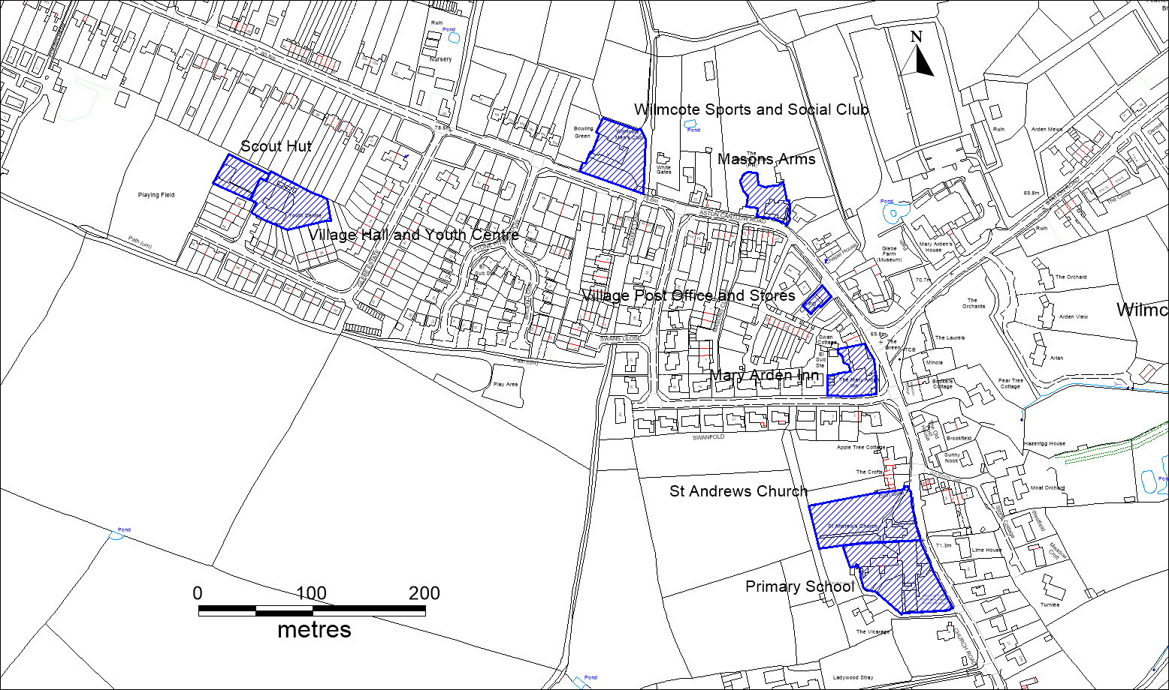

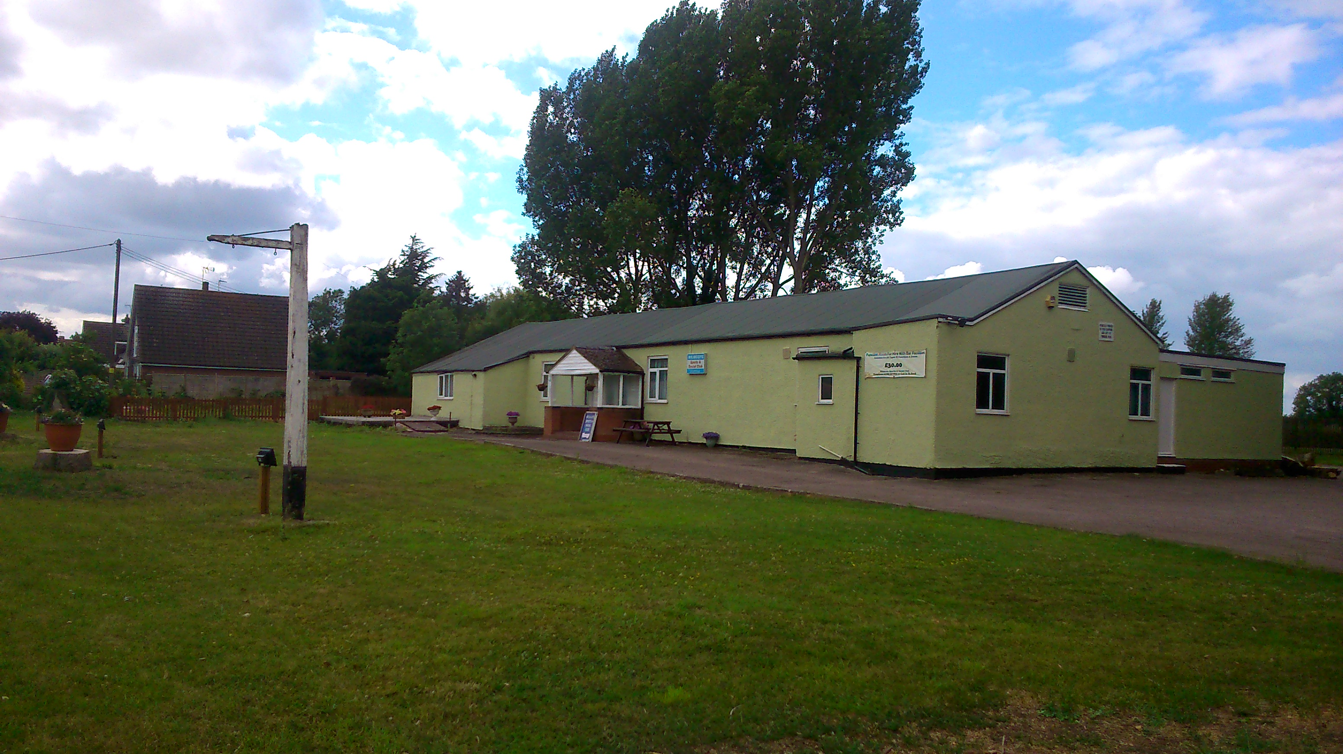
viii Wilmcote Sports and Social Club
POLICY WP8 – LOCAL GREEN SPACES
The local green spaces listed below (and shown on Figure 10) will be protected. Development of these local green spaces will only be permitted in very special circumstances. That is, when the harm to the local green space and any other harm is outweighed by other material considerations.
- The Green
- Field opposite Mary Arden’s House
- Willow Play Area and Playing Field
- Glebe Playing Field
Background/Justification
NPPF (paragraphs 76 and 77) gives local communities the opportunity to identify for special protection the green areas of particular importance to them. These local green spaces should be:
- In reasonably close proximity to the community they serve;
- Demonstrably special to a local community and hold a particular local significance (e.g. because of its beauty, historic significance, recreational value, tranquillity or the richness of its wildlife); and
- The area should be local in character and not an extensive tract of land.

Figure 10. Protected Local Green Spaces
(© Crown copyright and database rights [2015] Ordnance Survey 100055940 Wilmcote Parish Council (Licensee) License number 100054743)
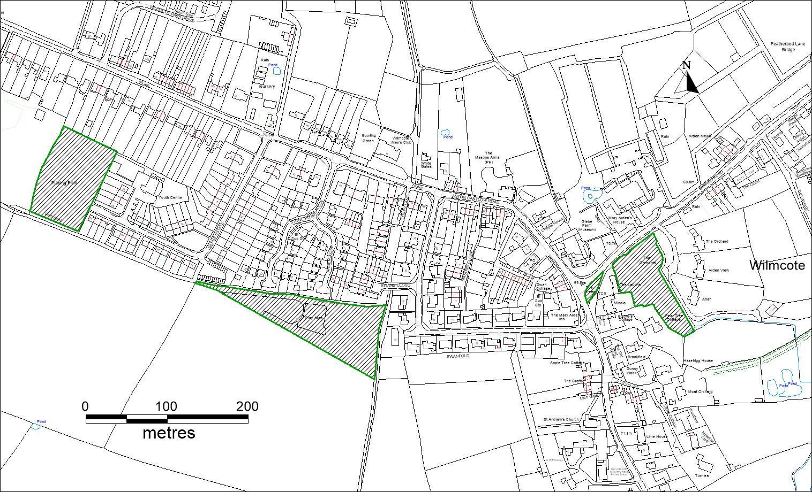
Key
Protected Local Green Space

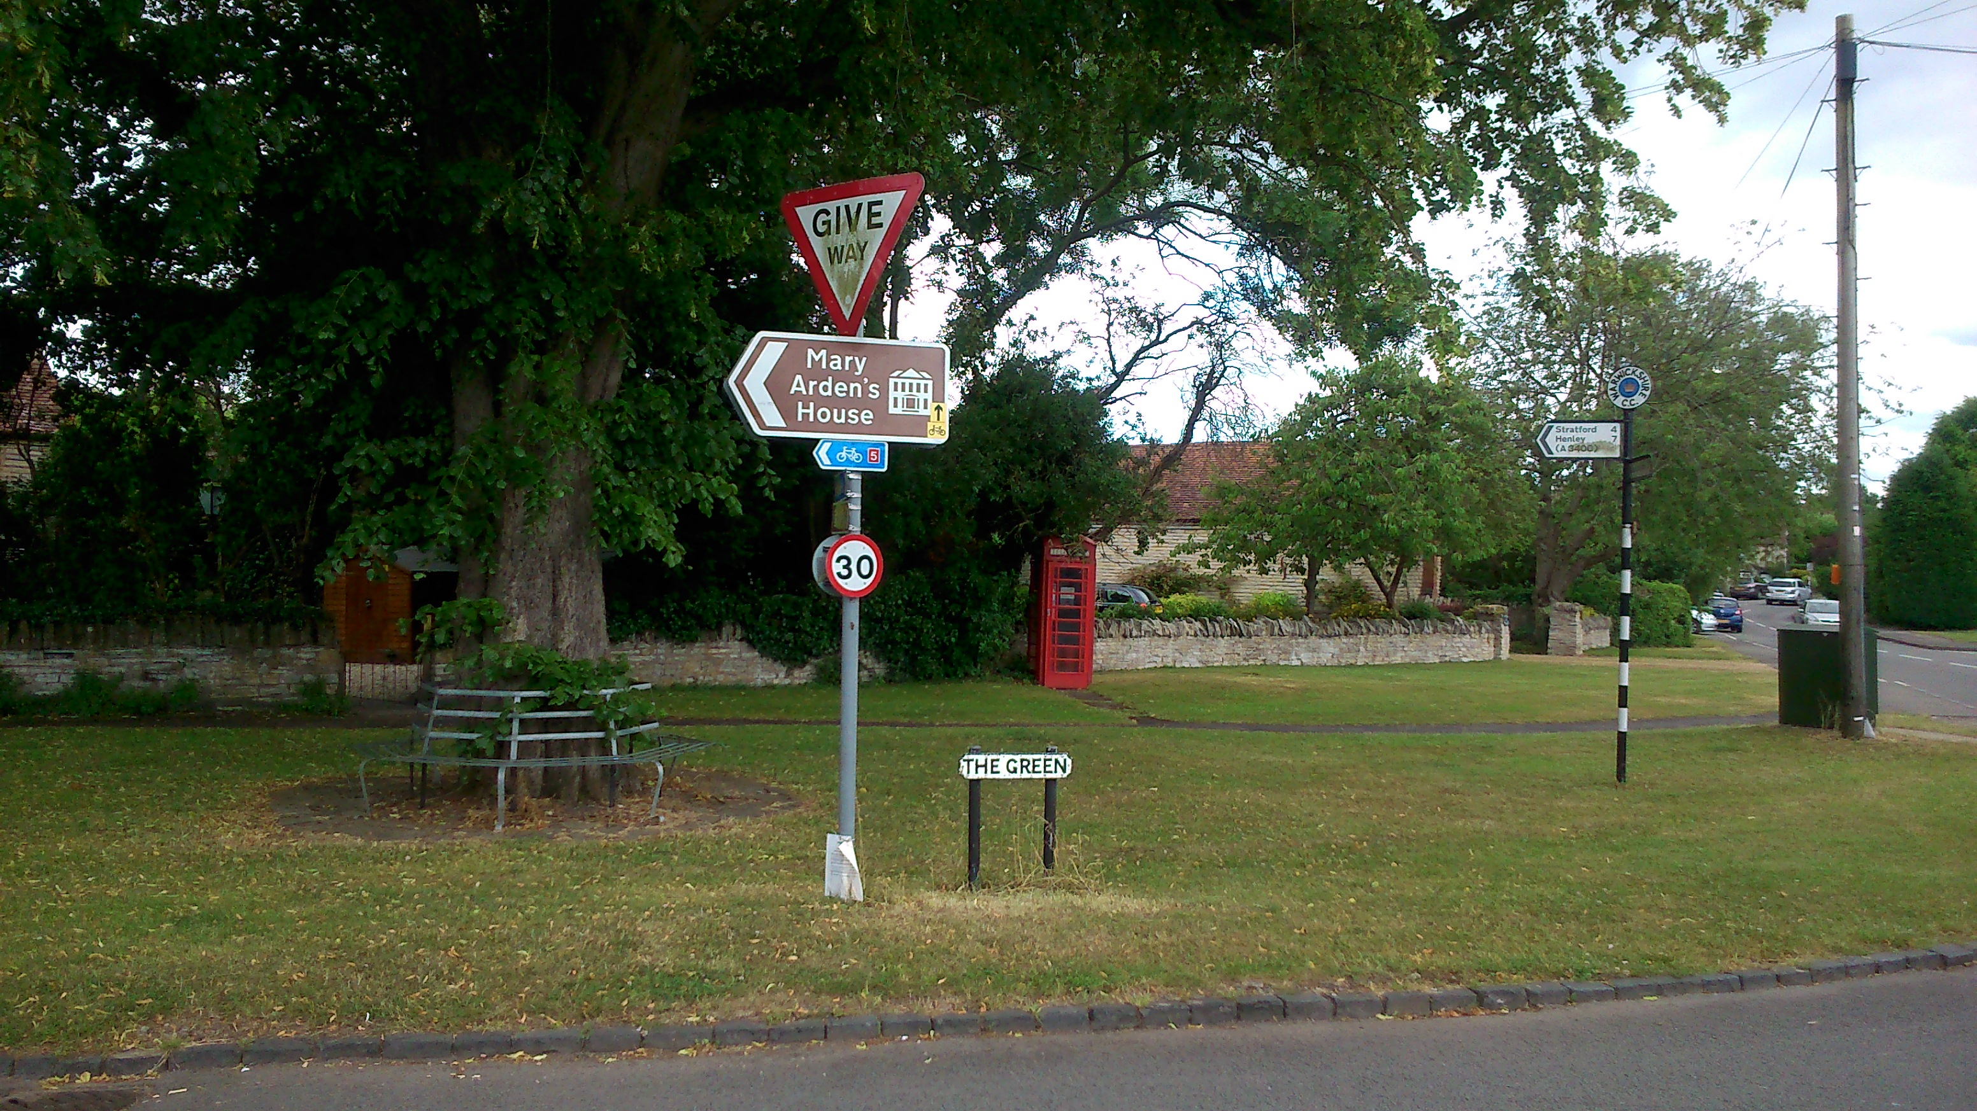
ix The Green, Wilmcote
Following an assessment of green spaces in the parish, the following have been identified as meeting the criteria in the, Table 1.

Table 1 - Local Green Spaces in Wilmcote Parish
Name of  Green Space | Proximity to the local community | Demonstrably Special and holds a local significance | Local in Character | Not an Extensive Tract of Land
The Green | Located in village centre. | Small open space in village centre. Seating, telephone box, etc. | Yes. | Small open space.
The field opposite Mary Arden’s House | Located in village centre. | Open space near centre of village, in Conservation Area and Listed Buildings. | Yes | Not an extensive tract of land. Area is bounded on all sides by built form of the village.
The Willow Play Area and its adjoining playing field (public) | Near village centre and local housing. | Provides recreation facilities for local community and children’s play. | Yes | Not an extensive tract of land.
The Glebe playing field (public) | Near village centre and local housing. | Playing field. | Yes | Small playing field with housing on two sides and separated from surrounding countryside by high hedge.

OBJECTIVE 3 – To manage future housing growth in Wilmcote, Pathlow and the wider parish
POLICY WP9 – NEW HOUSING DEVELOPMENT IN WILMCOTE VILLAGE
New housing development within the existing village of Wilmcote will be supported when it is limited infilling, including residential gardens, and can demonstrate that it meets the following criteria:
- It would not lead to encroachment into the open countryside and is infilling within an existing built-up frontage or infilling on a small plot within the existing built envelope of Wilmcote village;
- It would not have an unacceptable adverse impact on residential amenity for existing and future residents;
- It would not result in an unacceptable loss of garden space for an existing property, or properties;
- Provision of off-street car parking for a minimum of two cars is provided;
- It would not result in a reduction in off-street car parking; and
- It would not harm the visual amenity of the Green Belt and the setting of any designated or non-designated heritage assets.
New housing development outside of the existing village will be considered inappropriate development unless it is limited affordable housing to meet an identified local community need. Such housing should not compromise the purposes and visual amenity of the Green Belt. Any site identified for such homes must also be in close proximity to existing local services, facilities and be in reasonable walking distance of local public transport.
The occupancy, and future occupancy, of these homes will be limited in perpetuity to people with a local connection by use of an appropriate planning obligation.

Background/Justification
Wilmcote village is “washed over” by the Green Belt. Existing and emerging strategic planning policy, in line with national planning policy contained in the NPPF, allows limited infilling in such settlements. 85% of respondents to the neighbourhood plan survey agreed that limited infilling was the preferred form of future housing development.
Policy WP9 will be used to manage future infill housing development in the village. The policy will seek to ensure that such development does not encroach on the open countryside and lead to development that will undermine the purposes of the Green Belt. Such development should, therefore, be located within the existing built envelope of Wilmcote village. This could be a vacant plot within an existing built frontage or the development of a small site within the confines of the existing village envelope.
Emerging planning policy in the Stratford-on-Avon District Council Core Strategy (Policy CS.25) allows for car parking standards to be set to address particular local circumstances. The rise in car ownership and the existing problems with on-street car parking, backed up by views in the residents’ survey mean there is a need to ensure that car parking provision is provided on-site at a minimum of two cars per new dwelling.
Limited affordable housing to meet an identified local community need will be supported when it is evidenced in a parish council approved local housing needs survey. The latest survey conducted by Warwickshire Rural Community Council identified a need for seven new homes in Wilmcote parish for people with a local connection and the specific need is for:
Housing association rent
• 1 x 2 bed house
• 1 x 2 bed flat or house
Private rent
• 1 x 2 bed house
Owner occupier
• 1 x 2 bed bungalow, adapted • 1 x 2 bed house
• 1 x 2 bed bungalow or house
• 1 x 3 bed house
This study also concluded that a future exercise could be carried out to identify a suitable piece of land to meet the seven local housing needs identified by this survey.
Partners in the land identification exercise should include:
• Wilmcote Parish Council
• Stratford-on-Avon District Council
• Warwickshire Rural Housing Association
• Local landowners
• Rural Housing Enabler for WRCC
Any new homes that are intended to meet these local needs should be accompanied by an appropriate planning obligation to restrict occupancy of the homes, in perpetuity, to people with a local connection.

POLICY WP10 – NEW HOUSING DEVELOPMENT IN PATHLOW
New housing development in Pathlow will only be supported when it meets a local need identified through an up to date local housing needs survey. When such a need has been identified such proposals should be:
- For small-scale affordable housing; and
- Be well related to the existing built form of the settlement and limit any incursion in to the open countryside.
Background/Justification
As a small settlement within the open countryside and “washed over” by the Green Belt, new housing development in Pathlow will be limited to small-scale affordable housing schemes that meet an identified local housing need. Such housing needs must be identified through an up-to-date local housing needs survey undertaken by the Parish Council or Stratford-on-Avon District Council.
Any new housing will be limited to affordable housing as defined in the NPPF, see Appendix 2 – Glossary of this document.

OBJECTIVE 4 – To promote good quality new buildings and to ensure suitable replacement, re-use and conversion of existing buildings
POLICY WP11 – PROMOTING GOOD DESIGN
All new development proposals should be of good quality design that responds sympathetically and positively to the surrounding local character. To ensure this is achieved development will be expected to demonstrate the following:
- preservation and enhancement of the local built, historic and natural environment;
- design that is good because it takes into account site characteristics and surroundings and has made appropriate use of:
- layout
- density
- siting
- scale
- height
- proportions and massing
- orientation
- architectural detailing
- landscaping and
- materials
- street scene
- design and materials compatible with surrounding buildings

- no significant adverse impact on residential amenity for existing and future residents;
- does not contribute to, or suffer from, adverse impacts arising from noise, light or air contamination, land instability or cause ground water pollution;
- seeks to utilise sustainable construction methods, minimises the use of non-renewable resources and maximises the use of recycled and sustainably sourced materials;
- where appropriate, opportunities are taken to minimise resource use and incorporate in the design, features (including renewable energy) that lead to low or zero carbon dioxide emissions;
- provides suitable and easy access for all members of the community;
- minimises opportunities for crime;
- can be easily adapted to accommodate changing lifestyles and technologies;
- includes adequate off-street car parking;
- for residential development, has a garden to meet the needs of existing and future residents;
- ensures, privacy, security and safety; and
- would not harm the visual amenity of the Green Belt.
Background/Justification
National planning policy requires good design. All future development proposals in the parish should be of good design. To ensure that this goal is achieved, Policy WP11 will be used to assess all development proposals in the parish.
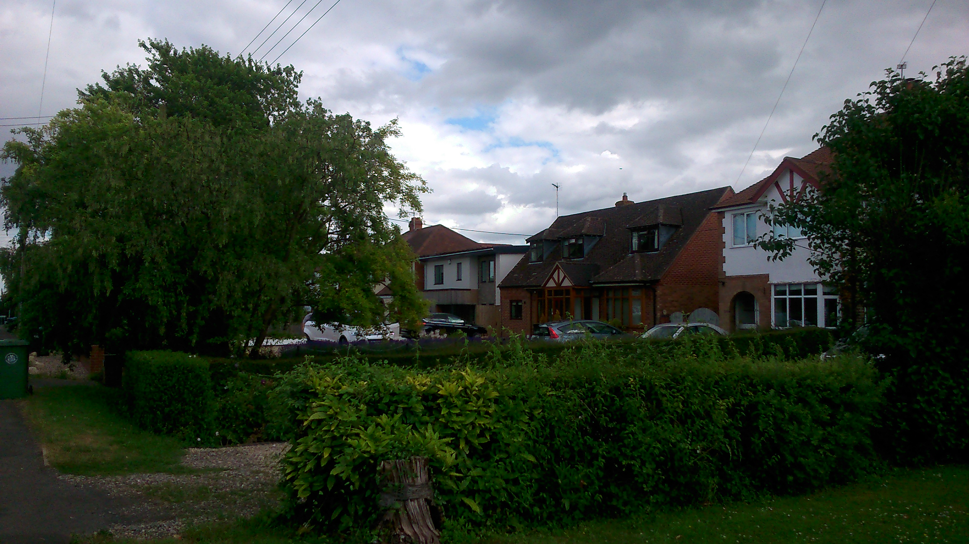
x A wide range of design styles
In terms of housing design, the Parish has a very diverse mix of house types and styles. The aim of Policy WP11 is to ensure that future housing development is not of any one style, or uses any particular type of material, but that wherever it is, it is of good quality and enhances its surroundings and is sympathetically designed to the highest environmental standards.
It is acknowledged that design is led by the developer and it would be inappropriate to dictate the detailed design of new houses, except to state that they should not be a basic box, lacking in character.
93% of residents agreed that good design following the principles above was important; and 99% agreed that privacy security and safety are very important.
Policy W11 acknowledges that design in the Parish is eclectic and that the most important objective is to achieve good quality design. Policy WP11, therefore sets out the criteria as to how this will be assessed. Poor design that fails to meet these criteria will be refused planning permission.

OBJECTIVE 5 – To promote leisure, recreation and tourism
POLICY WP12 – LEISURE AND RECREATION DEVELOPMENT
Within the existing village of Wilmcote proposals for new leisure and recreation uses will be supported when they meet the following criteria:
- They do not have an adverse impact on residential amenity;
- They do not have an adverse impact on designated and non-designated heritage assets and their setting;
- They do not have an adverse impact on privacy, safety and security; and
- They do not have an adverse impact on the openness or visual amenity of the Green Belt.
Outside of Wilmcote village such proposals will be supported when they are the provision of appropriate facilities for outdoor leisure and recreation, including small buildings essential for the running of such outdoor recreation, that would not conflict with the purposes of the Green Belt.
Background/Justification
National Green Belt planning policy seeks to encourage the beneficial use of Green Belt land once it has been defined. Wilmcote parish has a number of existing leisure, and recreation assets, including Mary Arden’s House, the Stratford-upon-Avon Canal, and National Cycle Route No. 5 runs through the parish. These benefit visitors, the local community and the local and wider economy.
Mary Arden’s House is one of the five Shakespeare houses within the Stratford-on-Avon area. The Shakespeare Site Tour Bus comes through the village all year and The Shakespeare Birthplace Trust (SBT) is putting plans together for year-round opening of Mary Arden’s House.
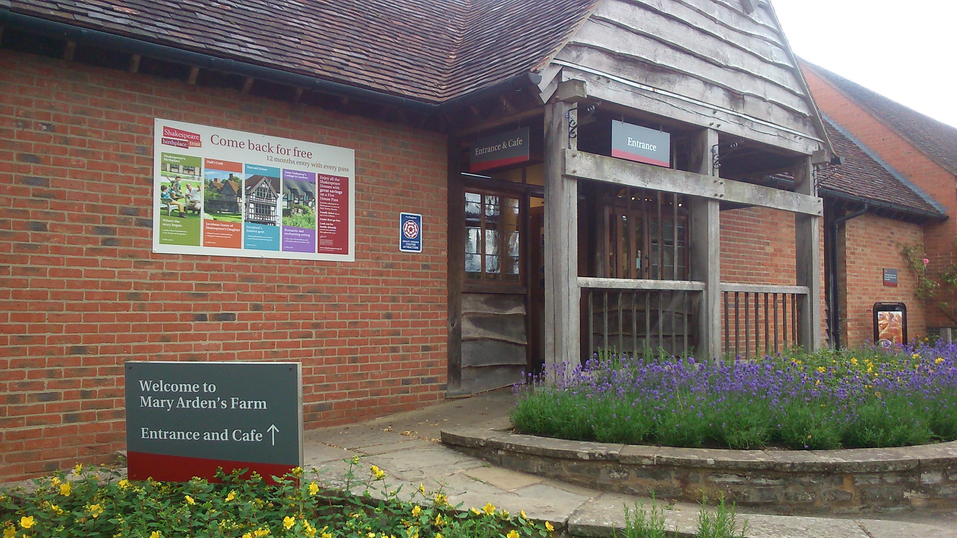
xi Mary Arden's Farm

OBJECTIVE 6 – To promote privacy, safety and security
POLICY WP13 – SAFER TRAVEL AND TRAFFIC
Where appropriate, new development should include suitable measures to improve accessibility and safety for all modes of travel. In particular development should seek to incorporate measures that provide alternatives to the use of private car such as walking, cycling and public transport. Where there are identified adverse traffic impacts arising from the proposed development, the applicant will be required to identify and incorporate measures to deal with these impacts.

Background/Justification
With the increasing use of cars to travel in and out of the village the speed of cars within the village boundary of Wilmcote and Pathlow is a problem and a concern to residents. The main ‘A’ roads that feed in to the village are 50 mph and although adequate signage exists to inform of the speed reduction to 30mph within the village this is not always observed by drivers.
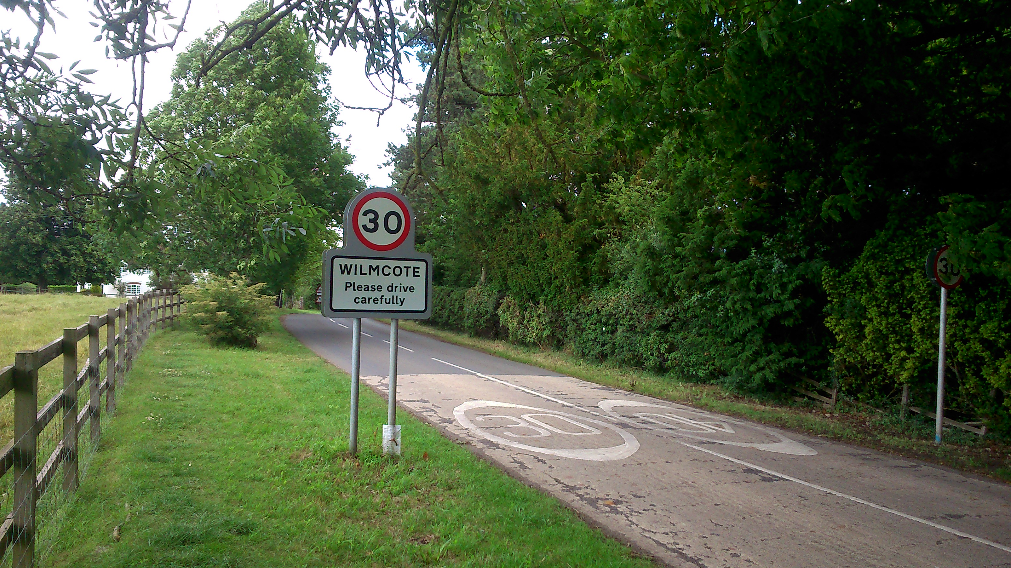
xii Well sign posted, but often ignored
There have been a number of road traffic accidents within the boundaries of the parish, resulting in varying degrees of damage and sadly several fatalities. Despite well-sited highway signage and markings in most parts of the parish, there are a significant number of road users who regularly exceed existing speed limits.
As well as seeking to address traffic issues through the planning system, the Parish Council have also identified the following supporting actions:
Supporting Action 1 - The Parish Council will work with Warwickshire County Council to review the existing speed limits in the village and seek measures to lower the speed limit around sensitive areas such as at the school, shop and railway station. In carrying out this review, the Parish Council will seek to identify a number of “Safety Zones” where measures to improve accessibility and highway safety will be prioritised and co-ordinated.
Supporting Action 2 - In sensitive areas where the risk of accident is greatest, such as around the school, village shop, railway station and Mary Arden Farm, the Parish Council will work with Warwickshire County Council and others to identify a number of Safety Zones, where co-ordinated action will be undertaken to identify and implement highway accessibility and safety improvements.
Car parking is an issue in the village, particularly at the station and Mary Arden’s House. New car parks in the Green Belt are considered inappropriate development. Any new car park development to address car parking at the station, Mary Arden’s House or elsewhere in the parish would have to be justified under the national planning policy test of “very special circumstances”. That is when “potential harm to the Green Belt by reason of inappropriateness, and any other harm, is clearly outweighed by other considerations” (para. 88 of NPPF).
The Parish Council will, therefore, support development proposals to provide new car parking areas when they do not harm the purposes of the Green Belt, the visual amenity of the Green Belt and residential amenity.
Within the village of Wilmcote many services and facilities attract cars and parking is increasingly becoming a major hazard. The railway station provides a service to both Birmingham and London, there is no car park for people driving in to the village to use the service and they are forced to park in the road.
Supporting Action 3 - The Parish Council will work with Warwickshire County and Network Rail to avoid off-street parking of cars at the railway station. We will also work with Warwickshire County Council to discourage the parking of cars on footpaths.
Tourism provides a valuable boost to the local economy and adds to an already vibrant local community. But the needs of tourism and the local community need to be balanced by encouraging tourism, such as allowing for ample coach access in and out of Mary Arden’s Farm but retaining the village’s rural lifestyle and image. For example, the impact of visitors’ parking of vehicles can cause difficulties at certain times for local residents, particularly during holiday periods. Similarly, the movement of tour buses can cause congestion at times, particularly past the school, and the risks that this, and other impacts, may present will need to be managed.
Supporting Action 4 - The Parish Council will work with Warwickshire County Council, Stratford-on-Avon District Council and the trustees of Mary Arden’s Farm to address car parking, access and other transport issues at the Farm site.

POLICY WP14 – FOOTPATHS, PAVEMENTS AND STREET LIGHTING
Where necessary, development proposals should seek to provide new footpaths and pavements and appropriate street lighting. These features should be designed to make the highway safer for all users and, in appearance, should be appropriate to the character of the surrounding area.
Background/Justification
This policy seeks to improve footpaths, pavements and street lighting in the area.
In particular, the area around the school is becoming increasingly unsafe at the beginning and end of the school day and to address this problem the Parish Council will work with Warwickshire County Council.
Within the existing village boundaries of Wilmcote and Pathlow, street lighting should be upgraded to current lighting technology to both reduce energy consumption and improve the effectiveness of each lighting point.
DEFRA is the government department with responsibility for overseeing the public right of way network. The Parish Council will work with key partners to review the footpath network in the parish so that it promotes a healthy community but also protects the privacy, safety and security of residents. DEFRA guidance on the management of the public right of way network states: “The Government acknowledge that for householders an intrusive footpath can have a substantial impact on their quality of life. This guidance therefore sets out revised government policy on the diversion or extinguishment of rights of way that pass through gardens. It effectively acts as a presumption to divert or extinguish public rights of way that pass through such properties where privacy, safety or security is a problem and exhorts confirming authorities to act on that presumption.”
As well as seeking to address traffic issues through the planning system, the Parish Council have also identified the following supporting actions:
Supporting Action 5 - The Parish Council will work with Warwickshire County Council to review the footpath along Church Road in the vicinity of the primary school, to improve highway safety as part of a wider initiative to introduce a “Safety Zone” in this area, see Policy WP13 above.
Supporting Action 6 - The Parish Council will work with key partners to review the footpath network in the parish to promote a healthy community but also protect the privacy, safety and security of residents.

8 Monitoring and Review
8.1 Plans are only valuable when kept up to date. The Parish Council will monitor the policies and proposals in the plan on an annual basis. A monitoring report will be prepared on the plan and presented to the Annual General Meeting in May each year.
8.2 Where the need for change is identified we will work with Stratford-on-Avon District Council to produce updates and amendments where necessary.
8.3 Should significant sections of the plan become out of date we will look to review the whole document by producing a new plan following the Neighbourhood Development Planning procedure.

9 How to Comment on this Document
9.1 The Wilmcote Draft Neighbourhood Development Plan has been published for a period of formal consultation between 1st March and 12th April 2016.
9.2 Copies of the plan and response forms can be viewed on line in the Our Neighbourhood Plan section on the Wilmcote Neighbourhood Planning Group web site. On these pages you can also find copies of the questionnaire and the evidence base used to develop the draft NDP.
9.3 Copies of the Plan can be viewed at The Village Shop where three copies will be available for loan. You can also pick up response forms here.
9.4 You can send your views on the draft NDP, preferably by using one of the response forms to the Parish Council Clerk, Liz Butterworth, either by email: lizbutterworth@btinternet.com; or by post to: The Clerk to the Parish Council, Liz Butterworth, Alne View, Pathlow, CV37 0ES.

Appendix 1 - Wilmcote and Pathlow Neighbourhood Plan Community Communications
- Residents Communication
Introductory Meeting at Village Hall | 21st October 2013
Information leaflet to Residents | 12th January 2014
Update leaflet no.1 to Residents | April 2014
Invitation leaflet to Open Meeting | June 2014
Open Meeting at Village Hall | 26th June 2014
Update leaflet no.2 to Residents | July 2014
Update leaflet no.3 to Residents | December 2014
Leaflet and Survey questionnaire to Residents | January 2015
Open Meeting at Village Hall | 1st February 2015
Update leaflet no.4 and survey results | May 2015
Invitation leaflet to Open Meeting | June 2015
Open Meeting at Village Hall | 27th June 2015
Update leaflet no.5 to Residents | October 2015
Informal Consultation Public Meeting at Village Hall | 30th October 2015
Informal Consultation Public Meeting at Village Hall | 20th November 2015
Update leaflet no.6 to Residents | March 2016

- Sector Communications
Interviews took place with specific parties during the Spring/Summer of 2014 to establish their future plans over the next 10 to 20 years. Individual reports can be seen on the website.
The Sectors included:
(i) Commercial /Industrial /retail interests
Businesses interviewed and dates are detailed below:

- The Village Stores - 28/5/2014
- Edward Brain and Sons – 12/6/2014
- Masons Arms/Enterprise Inns – 12/6/2014
- Mary Arden Inn/Greene King – 12/6/2014
- Shakespeare Trust - 25/6/2014
- Bishopton Hill Farm - 1/7/2014
- Moor Farm Stud/King/Murphy - 11/7/2014
- Moor Farm Stud/King/Murphy (2) – 23/8/2014

(ii) Amenities within Village/Parish

Church - had discussions and meetings with various village residents and with children at the school who use the church for a “messy church” activity.
Primary School - meeting with Mrs Banyard 16/5/14, Dep. Head of Wilmcote C of E Primary School.
Village Hall - conversations with Mrs Deacon 25/5/14, Chair of Village Hall Committee.
Scout Hut and Grounds - discussions with Akela Paul.
Play Areas - met with Mother and Toddler Group (Little Minnows).
Social Club - information has been provided by the committee of the social club.
Village Green - general opinion is that people like the village green as it is, particularly for the Christmas carol service and Nativity display.
Car Parking - general opinion is that parking in the village in some areas is difficult and dangerous.
Canal and associated areas - the canal is regularly used by cyclists and walkers.
Health care - have discussed with local GPs the provision of healthcare in Wilmcote. The village is too small to support a GP surgery but we do have access to a prescription drop off service.
(iii) Infrastructure and Utilities
BT Openreach Email and Email response from Bill Murphy
Virgin Media Email but no response from Duncan Watts
Talk Email but no response from John Rees
Vodafone Email and phone response from Richard Perry
West Mercia Police letter
Environment Agency groundwater map
Severn Trust map request
Canal & River Trust comments
SDC Water Cycle letter
London Midland Railways
Leamington & Stratford Lines
Network Rail
Land Drainage
Coal Authority
Western Power Distribution

(iv) Housing

Ten businesses in Stratford, which deal with the sale and rental of private domestic property, were visited, to try and get some feel for the demand for new property in the parish.
Publications Reviewed:
Warwickshire Observatory website
ONS census 2011 website
ONS Neighbourhood Statistics website
English Heritage website
Wikipedia website (entries for Wilmcote amongst others)
Stratford-on-Avon District Review 2009

(v) Environmental

Meeting with Shakespeare Birthplace Trust (Alan Griffith and Abi Moore), 25th June 2014 at Mary Arden’s House
Meeting between Deanna Fernie and Alan Bailey (Chair, Billesley Conservation Society) August 27, 2014
Email correspondence and phone conversations with Nicholas Butler, Volunteer Planning Officer for the Council for the Protection of Rural England, Warwick Office, August/September 2014
Email correspondence between David Lowe (Chief Ecologist, WCC Ecology Unit) and Jamie Perry, 29 August/8 Sept 2014
Email correspondence between Katherine Burnett (Canals and Rivers Trust) and Jamie Perry/Alan Griffith, 4-12 Sept 2014
Email correspondence between Alistair Welch (Natural England) and Jamie Perry, 29 August and 10 September 2014
Email correspondence between Ben Wallace, HER, Warwick and Deanna Fernie, July and 5 September 2014
Email correspondence between Peter Boland, Historic England and Deanna Fernie, 7 August, 18 September 2014
Peter Boland, Historic England: telephone conversation with Deanna Fernie, October 2, 2014.
Environment Presentations by Peter Boland, Ben Wallace and David Lowe were attended at the SDC May 15 2015 (Colin Ray and Deanna Fernie)
Peter Boland, Historic England email correspondence with Deanna Fernie following submission of Environment Sector report to the above three presenters, 5 July, 16 July and 13 August, 2015.
Meeting between David Lowe (Principal Ecologist, Warwickshire Ecology Unit) August 19, 2015 and email on Aug 19, and August 28 following submission of draft Environment Sector report.
- General Communications
To ensure that the public could communicate with the Neighbourhood Planning Group established media links, these included:
- Facebook Page
- Web pages within website of Wilmcote Parish Council.
All minutes and reports associated with actions taken by the NPG can be found at www.wilmcotepc.co.uk/neighbourhoodplanninggroup
Within these webpages is a ‘Contact us’ link.
Flyers were distributed to each household; copies were also pinned on all 3 notice boards in the parish.
For Residents with no have access to email a contact address was included on correspondence.
- SDC Liaison
Reports were issued to SDC Planning department representative.
Appendix 2 – Glossary
Affordable housing: Social rented, affordable rented and intermediate housing, provided to eligible households whose needs are not met by the market. Eligibility is determined with regard to local incomes and local house prices. Affordable housing should include provisions to remain at an affordable price for future eligible households or for the subsidy to be recycled for alternative affordable housing provision.
Social rented housing is owned by local authorities and private registered providers (as defined in section 80 of the Housing and Regeneration Act 2008), for which guideline target rents are determined through the national rent regime. It may also be owned by other persons and provided under equivalent rental arrangements to the above, as agreed with the local authority or with the Homes and Communities Agency.
Affordable rented housing is let by local authorities or private registered providers of social housing to households who are eligible for social rented housing. Affordable Rent is subject to rent controls that require a rent of no more than 80% of the local market rent (including service charges, where applicable).
Intermediate housing is homes for sale and rent provided at a cost above social rent, but below market levels subject to the criteria in the Affordable Housing definition above. These can include shared equity (shared ownership and equity loans), other low cost homes for sale and intermediate rent, but not affordable rented housing.
Homes that do not meet the above definition of affordable housing, such as “low cost market” housing, may not be considered as affordable housing for planning purposes.
Aged or veteran tree: A tree which, because of its great age, size or condition is of exceptional value for wildlife, in the landscape, or culturally.
Ancient woodland: An area that has been wooded continuously since at least 1600 AD.
Archaeological interest: There will be archaeological interest in a heritage asset if it holds, or potentially may hold, evidence of past human activity worthy of expert investigation at some point. Heritage assets with archaeological interest are the primary source of evidence about the substance and evolution of places, and of the people and cultures that made them.
Best and most versatile agricultural land: Land in grades 1, 2 and 3a of the Agricultural Land Classification.
Birds and Habitats Directives: European Directives to conserve natural habitats and wild fauna and flora.
Conservation (for heritage policy): The process of maintaining and managing change to a heritage asset in a way that sustains and, where appropriate, enhances its significance.
Community Infrastructure Levy: A levy allowing local authorities to raise funds from owners or developers of land undertaking new building projects in their area.
Community Right to Build Order: An Order made by the local planning authority (under the Town and Country Planning Act 1990) that grants planning permission for a site-specific development proposal or classes of development.
Designated heritage asset: A World Heritage Site, Scheduled Monument, Listed Building, Protected Wreck Site, Registered Park and Garden, Registered Battlefield or Conservation Area designated under the relevant legislation.
Development plan: This includes adopted Local Plans, neighbourhood plans and the London Plan, and is defined in section 38 of the Planning and Compulsory Purchase Act 2004.
Economic development: Development, including those within the B Use Classes, public and community uses and main town centre uses (but excluding housing development).
Ecological networks: These link sites of biodiversity importance.
Geodiversity: The range of rocks, minerals, fossils, soils and landforms.
Green infrastructure: A network of multi-functional green space, urban and rural, which is capable of delivering a wide range of environmental and quality of life benefits for local communities.
Heritage asset: A building, monument, site, place, area or landscape identified as having a degree of significance meriting consideration in planning decisions, because of its heritage interest. Heritage asset includes designated heritage assets and assets identified by the local planning authority (including local listing).
Historic environment: All aspects of the environment resulting from the interaction between people and places through time, including all surviving physical remains of past human activity, whether visible, buried or submerged, and landscaped and planted or managed flora.
Historic environment record: Information services that seek to provide access to comprehensive and dynamic resources relating to the historic environment of a defined geographic area for public benefit and use.
International, national and locally designated sites of importance for biodiversity: All international sites (Special Areas of Conservation, Special Protection Areas, and Ramsar sites), national sites (Sites of Special Scientific Interest) and locally designated sites including Local Wildlife Sites.
Local planning authority: The public authority whose duty it is to carry out specific planning functions for a particular area. All references to local planning authority apply to the district council, London borough council, county council, Broads Authority, National Park Authority and the Greater London Authority, to the extent appropriate to their responsibilities.
Local Plan: The plan for the future development of the local area, drawn up by the local planning authority in consultation with the community. In law this is described as the development plan documents adopted under the Planning and Compulsory Purchase Act 2004. Current core strategies or other planning policies, which under the regulations would be considered to be development plan documents, form part of the Local Plan. The term includes old policies which have been saved under the 2004 Act.
National Trails: Long distance routes for walking, cycling and horse riding.
Neighbourhood Development Order: An Order made by a local planning authority (under the Town and Country Planning Act 1990) through which Parish Councils and neighbourhood forums can grant planning permission for a specific development proposal or classes of development.
Neighbourhood plans: A plan prepared by a Parish Council or Neighbourhood Forum for a particular neighbourhood area (made under the Planning and Compulsory Purchase Act 2004).
Older people: People over retirement age, including the active, newly-retired through to the very frail elderly, whose housing needs can encompass accessible, adaptable general needs housing for those looking to downsize from family housing and the full range of retirement and specialised housing for those with support or care needs.
Open space: All open space of public value, including not just land, but also areas of water (such as rivers, canals, lakes and reservoirs) which offer important opportunities for sport and recreation and can act as a visual amenity.
Original building: A building as it existed on 1 July 1948 or, if constructed after 1 July 1948, as it was built originally.
People with disabilities: People have a disability if they have a physical or mental impairment, and that impairment has a substantial and long-term adverse effect on their ability to carry out normal day-to-day activities. These persons include, but are not limited to, people with ambulatory difficulties, blindness, learning difficulties, autism and mental health needs.
Planning condition: A condition imposed on a grant of planning permission (in accordance with the Town and Country Planning Act 1990) or a condition included in a Local Development Order or Neighbourhood Development Order.
Planning obligation: A legally enforceable obligation entered into under section 106 of the Town and Country Planning Act 1990 to mitigate the impacts of a development proposal.
Playing field: The whole of a site which encompasses at least one playing pitch as defined in the Town and Country Planning (Development Management Procedure) (England) Order 2010.
Pollution: Anything that affects the quality of land, air, water or soils, which might lead to an adverse impact on human health, the natural environment or general amenity. Pollution can arise from a range of emissions, including smoke, fumes, gases, dust, steam, odour, noise and light.
Previously developed land: Land which is or was occupied by a permanent structure, including the curtilage of the developed land (although it should not be assumed that the whole of the curtilage should be developed) and any associated fixed surface infrastructure. This excludes: land that is or has been occupied by agricultural or forestry buildings; land that has been developed for minerals extraction or waste disposal by landfill purposes where provision for restoration has been made through development control procedures; land in built-up areas such as private residential gardens, parks, recreation grounds and allotments; and land that was previously-developed but where the remains of the permanent structure or fixed surface structure have blended into the landscape in the process of time.
Priority habitats and species: Species and Habitats of Principle Importance included in the England Biodiversity List published by the Secretary of State under section 41 of the Natural Environment and Rural Communities Act 2006.
Renewable and low carbon energy: Includes energy for heating and cooling as well as generating electricity. Renewable energy covers those energy flows that occur naturally and repeatedly in the environment – from the wind, the fall of water, the movement of the oceans, from the sun and also from biomass and deep geothermal heat. Low carbon technologies are those that can help reduce emissions (compared to conventional use of fossil fuels).
Rural exception sites: Small sites used for affordable housing in perpetuity where sites would not normally be used for housing. Rural exception sites seek to address the needs of the local community by accommodating households who are either current residents or have an existing family or employment connection. Small numbers of market homes may be allowed at the local authority’s discretion, for example where essential to enable the delivery of affordable units without grant funding.
Setting of a heritage asset: The surroundings in which a heritage asset is experienced. Its extent is not fixed and may change as the asset and its surroundings evolve. Elements of a setting may make a positive or negative contribution to the significance of an asset, may affect the ability to appreciate that significance or may be neutral.
Significance (for heritage policy): The value of a heritage asset to this and future generations because of its heritage interest. That interest may be archaeological, architectural, artistic or historic. Significance derives not only from a heritage asset’s physical presence, but also from its setting.
Site of Special Scientific Interest: Sites designated by Natural England under the Wildlife and Countryside Act 1981.
Stepping stones: Pockets of habitat that, while not necessarily connected, facilitate the movement of species across otherwise inhospitable landscapes.
Strategic Environmental Assessment: A procedure (set out in the Environmental Assessment of Plans and Programmes Regulations 2004) which requires the formal environmental assessment of certain plans and programmes which are likely to have significant effects on the environment.
Wildlife corridor: Areas of habitat connecting wildlife populations.
Winding hole: A widened area of a canal, used for turning a canal boat such as a narrowboat. "Winding" is pronounced as in a flow of air, not as in to rotate (source: Wikipedia).


Appendix 3 – Wilmcote Conservation Area (Source: Stratford-on-Avon District Council)

2011 Census

