WILMCOTE PARISH COUNCIL

Mrs. E. Butterworth “Alne View”

Clerk Pathlow,
Stratford on Avon

CV37 OES
Tel: 01789 268998
lizbutterworth1@btinternet.com

Mr. M. Neal
Neighbourhood Planning Officer
Stratford on Avon District Council
Elizabeth House
Church Street
Stratford on Avon
CV37 6HX

1st November 2016

Dear Mr. Neal

Neighbourhood Area Application

This is a formal application from the Neighbourhood Plan Committee of the Wilmcote Parish Council to Stratford on Avon District Council to have our Parish formally designated as a Neighbourhood Plan Area under Part 2, Regulation 5, of the Neighbourhood Planning (General) Regulations 2012. The regulation states that an application submitted to the local planning authority must include:

(a) a map which identifies the area to which the area application relates;
(b) a statement explaining why this area is considered appropriate to be designated as a neighbourhood area; and
(c) a statement that the organisation or body making the area application is a relevant body for the purposes of section 61G of the Town and Country Planning Act 1990 (as amended).

The following is submitted:

(a) A map showing the area delineated by the boundary of the Parish attached

(b) We consider our Parish boundary to be appropriate to define the Neighbourhood Plan Area as this encompasses the village of Wilmcote and its environs, and is the area that is relevant to our local community for neighbourhood planning.

(c) Under Section 61G (2) of the Town and Country Act 1990, a relevant body is defined as a parish council or an organisation or body which is, or is capable of being designated as a neighbourhood forum. This application is submitted by Wilmcote Parish Council which is considered to be a relevant body for the purposes of this application and is, therefore, authorised under Section 61G (2).

Yours sincerely,

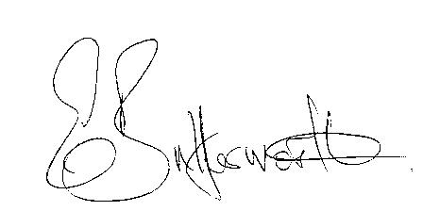

Mrs. E. Butterworth
Clerk

Enc.

